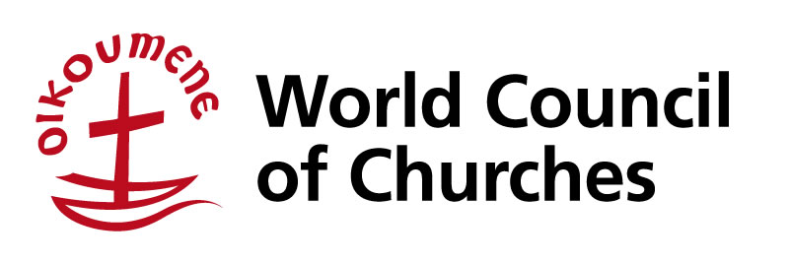

**English version of “The Théopopettes” special episode**  “**WCC** – **W**e **C**are About **C**hildren“

You can download all the episodes [here](https://oikoumene.photoshelter.com/galleries/C0000cXWJl_CjN60/G00005cQ6d2k6Qpk/We-Care-About-Children-Les-Theopopettes)

|  |  |  |  |
| --- | --- | --- | --- |
|  | **Title** | **Theme** | **Length** |
| 1 | What are these mysterious letters? | What is the WCC? | 9:56 min |
| 2 | What is a church? | The church | 2:13 min |
| 3 | Churches are for children too | Child participation | 5:29 min |
| 4 | More rights for children | Child Rights | 3:06 min |
| 5 | We care about children | How churches implement child right | 4:56 min |
| 6 | Work is like chocolate… | There is a lot of work to implement the Churches’ Commitments to Children – but it is fun if we do it together, children and adults! | 3:23 min |
| 7 | Different alike – Stronger together | Unity and diversity go together in mandate of the WCC | 6:40 min |
| 8 | Children come on board! | Call to children: Express yourselves in churches & participate in making churches more child-friendly | 3:24 min |
| **Extras/Bonuses** |  |  |  |
| 9 | Meet the buddies | Introduction to Théo & Popette (the puppets) | 3:02 min |
| 10 | Quiz on children’s rights | The Convention on the Rights of the Child | 2:27 min |

Recording of French version (live event at WCC on 21 November 2018): available here (40 minutes)