Stories from WV Mali

“One thing is certain: we cannot come out of this training being the same…” recounts Sylvie Kpakpo, P&C Director of WV Mali on the recently held CFC training organized for staff of WV Mali.
The impact of CFC had been felt right across the over 150 staff and their families present at the training. “The consequences of our actions and our words in creating a favorable environment both at home and at work is crucial for all of us to note. This training puts us face to face with the reality that we all have a responsibility and a role to play in making our homes and our workplaces remain harmonious places. Creating a pleasant environment is not only the affair of the other but of each of us” concludes Sylvie.
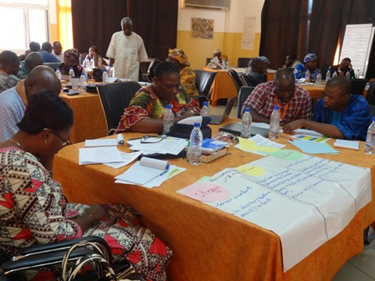
Once again, CFC is breaking new grounds in Mali. A few months ago, the CFC target was Faith leaders where participants made the discovery that “fullness of life for children begins at home”. Now, staff of WV Mali are on their way rejoicing, having made profound discoveries themselves from the training.
The training, described by a staff as “one unlike others” enabled staff to review their family lives from childhood in the light of concepts then little-known during their growing up years and to access their present family lives. Many realized they were unwittingly carrying some baggages from their childhood times into their present family lives.There were emotional moments during the training as staff looked back to their lives, and resolved to make amends in humility by asking for forgiveness from partners.

This is best captured by Samuel Diarra, Technical Director, WASH Operations, GC, based in Mali: '' It's a blessing for me and my wife to have taken part in this training. We had a new look at our own mistakes, our failures, but also our strengths. The module on the journey through our childhood until future of our family was a moment of high emotion. We remembered moments of joy and pain we've been through together and this has strengthened our ties advantage. As for the exercise of reasons for thanksgiving and opportunities of forgiveness, it allowed us to thank the Lord for all his grace on our family and gave us the opportunity to forgive each other…Today, every member of my family sees each other differently. We are closer together through the application of knowledge and practices learned during this training.. We communicate more and we understand better. I hope that this training be extended to young couples, for all religious confession to prepare them for family life' The Sharing of the oldest was enriching experiences for young and sometimes finding a solution to a challenge in a household became everyone's business. Solidarity, compassion, empathy, self-improvement, are as valuable as we felt in the room”.

This '' Journey '' allowed staff to appreciate the invaluable role of each family member in the pursuit of the spiritual nurture of children and their well-being. Colleagues who managed to come with their wives had the rare privilege of sharing this special time together learning and listing their similarities, differences challenges and strengths.
WARO, F&D Department, August, 2015.

Stories from Zambia
Mwansa Matthew, 28 years old, lives in Mumbi Village in Iyaya Ward of Mungui district in the northern Province of Zambia, and is married to Given Mwansa, 26; together, they have 3 children (2 girls and 1 boy) namely, Naomie, 6 years doing Grade One at Nkweto Community School and is a registered child; Ezron 4 years, and is also a registered child and Rosemary one and a half years old.
Matthew’s Community, Mumbi Village, believed that World Vision was a Satanist Organization that would initiate their children, and they refused to have child recruitment for Child Sponsorship Program in Bwacha ADP. They even refused the gift-in-kind (GIK) and all activities that World Vision would bring into the community. All local leaders’ efforts failed to convince the Mumbi Community to partner with World Vision in Child Sponsorship until March 2015 when Matthew from Seventh Day Adventist Church was identified and selected by World Vision Community Representative to be trained in Celebrating Families by Wampembe Lukonde, the Christian Commitments Manager from National Office.

After the training, Mumbi was transformed, and he started persuading his community by explaining to the members about World Vision’s identity. Matthew demonstrated by being the first parent to have his two children Naomie and Rosemary registered under Child Sponsorship. This made the entire community be convinced and believe that World Vision meant and was Christian Organization seeking to partner with communities to help vulnerable children and their households. The Community in Mumbi village has since registered its children, and accepted World Vision GIK and all programs after knowing the truth through Matthew’s mobilization meetings.

Matthew has been chosen to be the Child Minder for the Mumbi Community since then and the community is requesting for World Vision to continue scaling up its intervention in the area. Mathew is a deacon in the Seventh Day Adventist Church; he is contact lead farmer for food security and Economic development and was trained in conservation farming using God’s way of farming and has produced a high yield of groundnuts from a 3- Lima field after adopting the standards he was taught after the training. He is so pleased with World Vision for such initiatives and requested for more empowerment support from the organization. Matthew’s vision is to construct a better sizeable house and to also scale up groundnuts production to be a major contributor of enhancing food security in Bwacha ADP.
--by Suzyo Simfukwe, Zambia
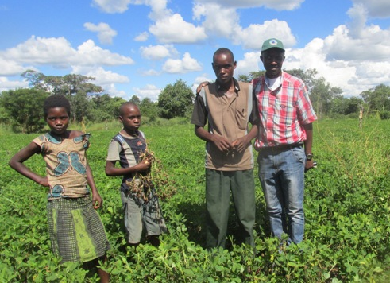
CC-2 Matthew with her daughter Naomie and his Nephew Chanda with the Northern Region Food Security Technical Advisor, Lasford Moono (in checked red shirt) posing for a photo in Matthew’s 3- Lima ground nuts field

Melina’s Journey
My God and Father, I thank you for this rare privilege to undergo this training; I also would like to appreciate the partners: World Vision Zambia for being the instruments to help me gain a deeper understanding of the role of a parent in families. I have never gone through this kind of training before; how I wish I had this privilege— this exposure early in life. It was the first time in twenty-seven years of marriage to go out as a couple and have a nice time together. I have been ministered to and I will not keep this knowledge to myself but share to as many families as possible. The many testimonies I have heard and the personalities of the facilitators, participants and the film shows have ministered to my life.
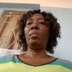
I have learnt that what pains me as a parent also pains the children and that, therefore, I have to put a stop to what would cause pain but instead should be able to resolve issues through discussions, counseling, training the children in the way they should go, and above all pray for my children. My plans to chase my son away from home for misbehaving have changed. I decided to forgive him, talk to him and continue praying for him. Besides the bible says I should forgive.
I have, therefore, engraved in my palm this note:
To you my child, I forgive you and I speak a blessing upon you and your family, you will walk in God’s favor. I will share my past, present and future dreams and hopes to rebuild our family.
--as compiled by Wampembe Lukonde, Christian Commitments Manager, WV Zambia
Stories from Ghana
Participant Testimony at the Joint Interfaith CF Workshop at Ayima Mansie & Kintampo ADPs, Ghana
“The Workshop has indeed impacted my life, both physically and spiritually. For instance, I have learnt that there is no hopeless person, there are seeds of goodness in everyone no matter how bad the person may seem to be. Also, I have learnt that there is the need to draw lessons from past experiences but not allowed the past experiences to affect me negatively. Also, I have learnt that there is always the need to ask for forgiveness and also to forgive others. I have also learnt to respect the views of children and also apply love languages in the home. I will do my best possible to use the knowledge acquired and the material obtained from the workshop to organize a retreat or seminar for my church leaders and the members.” --Cephas Boatet, The Church of Pentecost, Amoma District Pastor

A Personal Reflection of the CFC ToF workshop
“It was a great joy being part of this training. In fact, participating in the Celebrating Families ToT has just been a blessing to me and my family. This workshop was not just another workshop. It was a time for reflection and making effort to improve my personal responsibility and commitment to my family. The workshop was not one of those workshops that build us up to deliver on the job, but rather provided me with the tools to better understand my family and really appreciate them. This was about ‘me’ as a participant.”
“I have gained so much through the curriculum and I can see that it’s already showing in my family. Now I’m beginning to understand the love languages of my family members. I’m also making more effort to see the good in all people and appreciate them as such. I’m really ready to use this experience to support my ADP teams and the community at large. It was a wonderful journey during the training session and now I’m enjoying the benefits with my family. I pray for more grace so I can stick to all the commitments I made and live by them. I definitely plan to replicate this to a lot of people especially parents and the ADP staff.” -Frank Twum-Barimah, Ag. OBTL, WV Ghana

Reflections from Celebrating Families Regional
Workshop MEER
“Something we often forget because of the western mindset is that children come in packages (they are not isolated from their families and communities). So we empower parents, who are the best delivery system for SNC. In Georgia something amazing happened. There was a team of partners from WV Georgia who were representing a media arm in the country (who attended in the Celebrating Families Workshop). Now Celebrating Families (key messages from CF) is being broadcasted all over Georgia.
This workshop was something very personal, I really enjoyed it. I have a little bit of apprehension at first, however CF, was hands on, experiential, and culturally sensitive. We were asked to make a drawing of our hopes and dreams for my family and it was laminated and I put it in my study. I have 3 grandkids - when my grandkids come into my study, it has initiated a conversation and it continues stir up conversation with my kids.” -- Danut Manastireanu, Former Director of Faith and Development, MEER.

Stories from East Africa

“We went to manila for the pilot and then we launched CF in Tanzania. Our SMT said it needs to go to every ADP because it is a tool for Child Protection. So we developed a strategy for how to replicate this. Four people from each ADP – one faith leader, one parent, one teacher, and one staff were trained in the clusters. We trained 200 people and then they went to their ADPs to train another set of people. Total there have been 1000 plus people trained. And where we have Muslim friends, they actually asked us: “please allow us to come to the training.” We warned them that it was Christian material, but they still wanted to come. They appreciated the tool so much. One Muslim participant said, “This training has helped me to change my attitude on children and from now on I will teach both Christians and Muslims how they should treat children.” They also said, “please help us to come with our spouses – we need this for our spouses not only us.” My role is to nurture this group of facilitators – motivating and mentoring them . We have run this workshop in all 60 ADPs. – James Kesanta, Former CC Manager, WV Tanzania.
“I always had this feeling that my wife was bitter. While punishing the children, she would cane them so badly and but I never intervened to stop her. After the training, I went home and shared with her what we had learnt and how physical punishment doesn’t really help the child because in most cases we do it in anger. She apologized to the children and promised that she was going to try and change. Lately, she really tries to control herself. As a way of controlling her anger, when the children do something bad, she walks away and promises to cane them later but does not. Our children are happy and they are not living in fear of being beaten by their mother anytime. The relationship between the children and their mother has also improved.” --Charles Jjemba, community volunteer Uganda
Samuel and his wife Florence attended the training on the Celebrating Families Curriculum. They were so encouraged by the training that when they got home, they discovered the love languages of the children and resolved to improve on the way of communication as a family which greatly fostered unity. Through the activity of the wise builders, they discovered their areas of strength as well as areas of growth. They decided to capitalize on the areas of strength and that is helping them have a good healthy relationship.
At the end of the year, Samuel lost his job and he feels that the training set a good foundation for them as a family to receive the news. He says his wife was quite disappointed with him but the children talked to her and she changed in her ways. His family generally has been very supportive and expressed a lot of tolerance and patience as they make several adjustments.
Lastly, Samuel says they have started a family tradition where they visit the hospital in the neighborhood at the end of the year to bless the patients with clothes and food. - Mr. Samuel & Mrs. Florence Tuhairwe, community volunteers Uganda

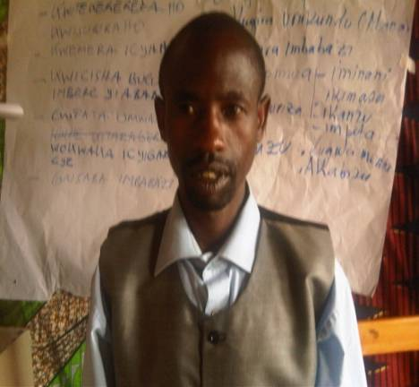
“I have four children and when they made mistakes, I used to punish and discipline my children in public thinking that I am doing something good to my children. Now I have learned that I have to discipline my children in love and help them to develop their self esteem. As I arrive home I will start with a clean vision to help my family as a whole particularly to my children. I will never again beat up my children either at home nor in public. I thank God for this opportunity to come and participate in this training. I will try to listen to my children and help them to plan how they will do what I ask them to do” - NDAGIJIMANA Silvestre, community volunteer WV Rwanda
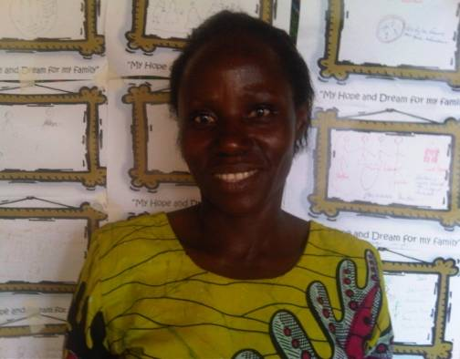
I am a mother of five children, and I work in the Kirambi Development Project. Every morning I report at the project, leaving my children at home with assigned activities. Unfortunately, at my arrival back home tired from work, I quarrel, beat up and abused my children without asking them about their struggles and trials they go through. However, in the Celebrating Families Training, I have learned how to treat my children and take care of them for their wellbeing and for my own benefit. I have really gained a deeper appreciation of the role of parents in the pursuit of children’s spiritual nurture and well-being. I broadened my understanding of the realities and context of the wellbeing of the healthy family. I have come to understand the processes that I will use to support my family towards wholeness. I will never again bit or abuse my children - MUKANDAYISABA Bernadette, community volunteer WV Rwanda

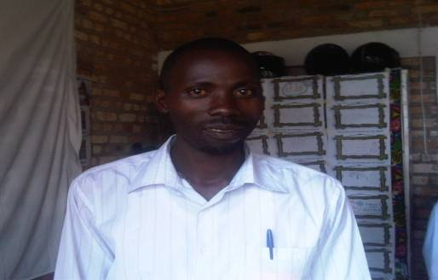
“I am a father of only one child but I cannot understand how I was not able to come to my senses and understanding that the Lord blessed me with only one child in my family. I have been very much confused and I used to beat up my child bitterly and foolishly even at the level of killing him. Throughout this training I come to realize that, I have been doing some abnormal things particularly for the discipline of my child. From now on, I will never again beat up my child; I will do my best to discipline my child in love for his wellbeing. I will not insult or hit him again and I will try my best to control my own emotions. I will do my best to show respect for my child and recognize his good intentions. I will try my best to let my child know that I want him to do the right things and I am there to help him learn new things and grow healthy. I will do my best to forgive my child for his misbehavior” - GATABAZI Etienne, community volunteer WV Rwanda

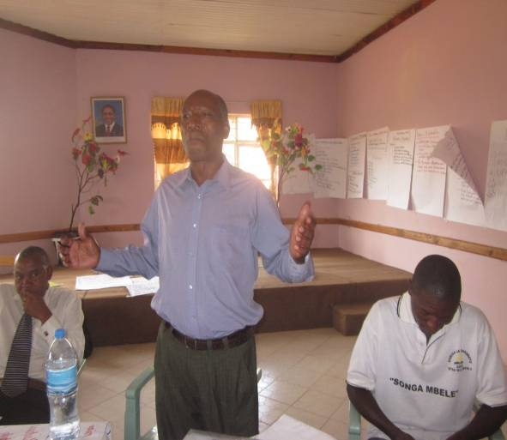
“In this workshop I saw the way both Christians and Muslims sat and worked together in peace and I said to myself ‘I wish this could spread through the whole of Tanzania including Zanzibar, there will be no conflict/fights between Muslims and Christians. It will be a peaceful country as it has been before’.

If possible this workshop should be conducted in the whole country where different religions will come together and learn with love and peace, and it will be all Blessings” Pastor Emmanuel Tenda, church partner, Tanzania

“Everybody in this seminar knows how messy my life has been. I have come a long way as I was swimming in the ocean. I thank God for this opportunity and I am very grateful the Makindube ADP which has been taking me to different workshops which have brought healing in my life. I thought I was fine in every aspect, but I have realized I have a long way to go as far as my family is concerned.
Through this workshop I have realized that, when I was raising my children, I ended wounding one of my daughters. I loved her so much I seriously beat her up and did all sorts of bad things to her, thinking by doing so I was expressing my lover to her. I have a lot to learn and I have decided to change my approach as a person, before I expect my family to change

In this workshop I have written an apology letter which I will deliver personally with my own hands to my daughter and with my own mouth will ask her to forgive me for all the wrongs I did to her
Indeed this workshop has transformed me and brought me closer to God”. -- Mr. Mrindwa Zephania (Parent), Mukindube ADP, Tanzania

Beatrice Raphael, a pastor from Kisongo/Makuyuni ADP attended a three-day workshop of Celebrating Families and went back and started spreading message of celebrating families to her church members and her neighboring families. She reports: “I have started seeing big changes in my church. Initially, parents did not value children. now, children are cared for, protected; conducive environment has been created for children. Even at my own home I am seeing changes. I learnt that even us parents need to ask for forgiveness from our children. At one point I asked for forgiveness from my child and she was surprised. She told me. ‘Mum, does it mean that even you grownups ask for forgiveness from children?’ Before, any mistake caused by a child was accompanied by beating. But nowadays, I have changed. Also, I have my neighbor who used to use abusive language to her child every then and now. I approached her and talked to her. It was hard for her to understand, but I kept sharing with her about the need to treat her child with respect and dignity. I have observed great changes in her. She once approached me and commented, Beatrice, you have helped me so much”

One of female parents gave the following testimony during a session on “The Signs of Wholeness and Brokenness. “I have a grandchild who is orphaned and is a bit mentally challenged; I have been scolding and beating him up very much thinking that I am helping him to be a better boy. Instead he started avoiding me, and preferring to stay at our neighbors especially when I am home. Whenever I am around he hides from me, I have been trying to befriend him and bring him closer but he has never been close to me. Now I know why? I have been mistreating him thinking I am teaching him good manners. I will change my approach from today because I have realized that it is not right for me to do so, may God forgive and help me.” – parent participant WV Tanzania

"Since I attended CFC workshop, I been transformed. I used to do everything alone without involving my wife, I never helped her to do any house work or take care for the children. After the workshop I started involving my wife in planning our ministry or family activities. I now help her to fetch the water from the well, bath the children, clean the house, cook etc. Neighbours find that very strange but both my wife and I are very happy. You should see my children they love it when I wash them.
Also, in Gorowa community, men never walk together with their wives, It is a shame for a man to be seen walking together with his wife, Since I conducted CFC workshop in my church, men have started changing. Many of them now come to church walking together with their wives. My desire is to make sure that I spread this knowledge to many villages" -- Pastor Tobotobo from African Inland Church, Tanzania

Stories from Vietnam

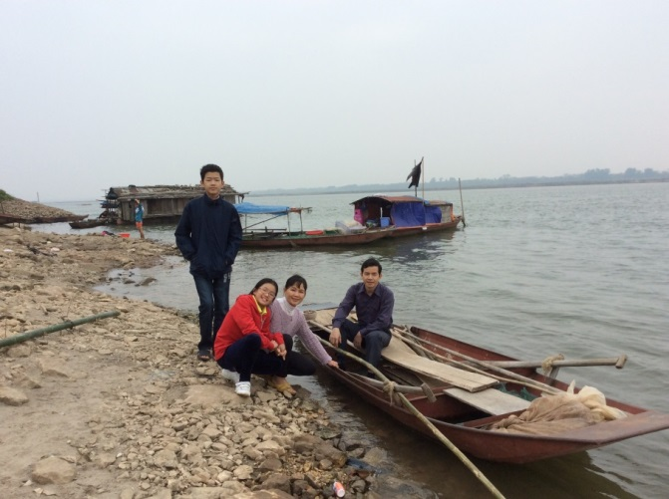
I attended the Celebrating Families workshop with my husband Bach Anh Tuan. We have been married for 17 years and have 2 children. My son Bach Ngoc Minh Chau is 15 years old while my daughter Bach Ngoc Minh Khue is 11 years old.It was the first time we attended such an interesting workshop together.
The biggest lesson from the workshop was that we identified what is like the “sand” and the “rock” in our family – what makes us stable or not and how we can apply it. Through the workshop, we learned that our children might be like us. They would be happy, if we could pay more attention to them, spend quality time with them rather than just correct their faults. We also tried to give the children more space for them to think and decide with our guidance rather than us just deciding and forcing them to follow our instruction. For example, before, whenever we saw them play video games or read cartoons, we would stop them and force them to go to the table to do homework. Now we discuss with them and made an agreement that they would not play until they complete all their homework and they also agreed to spend time helping us with some housework and some physical exercise.
We also talk more openly about what we have and how blessed we are. Therefore, we all can feel much happier and thankful for what God has done for us including the chance for us to be with each other learning the same things about parenting in the workshop.
Before the workshop, when I came home after a long tiring trip, I usually expected that my husband would know I was tired and help me more with the housework, even when I did not request for help. I felt so unhappy and often did the work with a negative attitude. After the workshop, I changed my attitude. If I am tired, I tell him that I am tired and ask him to do the work. I am happier because my husband sees my positive changes and he is also changing by offering me help when he notices that I am tired after a trip.
Both of us feel more open to speak our thoughts and share with each other rather than just keeping silent and waiting for the other to guess and do something for us. I also try to do as much housework, cooking, etc. as possible so that my mother in law can have some more time to relax and play with the kids. My family members then become more open and we have more laughter.--Giand Thi Thu Thuy, Zonal Programs Manger, WV Vietnam
My husband (Cung Dinh Hoan) and I attended the Celebrating Families workshop in Hanoi last December 2015. We have been married for 14 years and have 3 children: Cung Truc Thuc Doan (daughter – 13 years old), Cung Truc Thuc Anh (daughter – 9 years old), Cung Phuoc Vinh (son – 3 months).

It was our privilege to participate in such a wonderful workshop as a couple. During the workshop we were given time to recall our childhood memories, share our dreams for family, think about our weaknesses and thankfulness for GOD’s grace, love and forgiveness.

There were three things that were striking to us during the workshop:

#1: To see the goodness in others (Luke 15 – the story about the prodigal son): My husband admitted that his strength is to find others’ weakness. It sounds funny but actually it is true to many people, including myself. But to build strong and healthy relationships, we must find goodness. We decided to pray for this and ask GOD to help us to see the good in everyone, starting with husband and wife and our children.
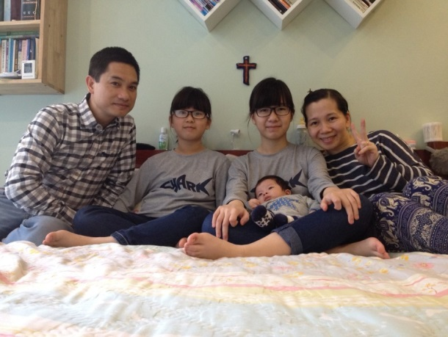
#2: To speak blessings/express love instead of blaming: I still remember how emotional I was when I wrote the love letter to our elder daughter. Parents are not expected to express love or speak blessings to children verbally in my generation, but show love through care, strict discipline. I cannot remember the last time my mother hugged me or said she loved me. I struggle when I am raising my own daughters, especially with my first. But in the Bible we know that GOD says He loves us many times and He also wants us to speak blessings to others, especially our family members. We pray that we will be able to freely express our love and speak blessings to our children.

#3: To discipline children with GOD given “Rod” or “Shebet”: It was a big challenge for us to understand the meanings of the word “Discipline” and to control our emotions. Disciplining our children in GOD’s way means to rescue, to guide, to protect and to comfort them.

Doing the exercise about Joys & Pains, we learned that parents often look and live with the past and future but our children live for present. They enjoy the little things and consider the fullness of life based on their present experiences. Communication helps us understand each other’s' needs and share our joys as well as our burdens.

Now, I find it easier to express my love to my husband and children by freely speaking blessings to them & praying for them daily.--Ngyuen Thuy Ahn, Sponsorship Service Operations Manager

