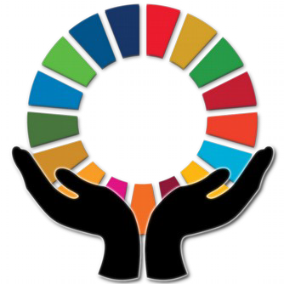

Keeping Faith in 2030: Religions and the
Sustainable Development Goals
Conference: call for presenters and participants
School of Oriental and African Studies, London, February 12th – 13th 2019
In recent years development agencies and donors in the West have begun to recognise the role of religions in their work and are now increasingly funding faith based organisations (FBOs) and projects that include religious actors. This corresponds to growing academic research on religion and development, and a wider interest in the role of religion in the public sphere. The Sustainable Development Goals (SDG) process is distinctive in a number of ways. First, it seeks to include local actors on a greater scale than before: in the consultation phase to decide the goals as well as in the implementation phase. Second, the SDGs are aimed at the Global North and the Global South.
This gives rise to some questions that will be the focus of this conference:
- In seeking to include local actors - including faith actors - to what extent has the SDG process placed a focus on the cultural and religious roots of development goals and practices in different settings? Has this impacted on the way that FBOs design their programming around the SDGs?
- Research on religions and development, including the SDGs, has focussed on the Global South. However, if the SDGs are aimed at the Global North and the Global South, what role are local faith actors in the UK and other Global North settings playing in the SDG process?
This conference is the fourth and final event of a research network called ‘Keeping Faith in 2030: Religions and the SDGs’ – funded by the Arts and Humanities Research Council in the UK– which aims to enhance international exchange about the role of religions in defining, implementing, and safeguarding ‘sustainable development’, as codified in the UN ‘Sustainable Development Goals’ (SDGs). The conference will begin with an overview and discussion of the findings of of the ‘Keeping Faith in 2030’ project. We also seek to invite academics and FBOs to present on the following:

1. Religions and the SDGs: bridging the gap between global programming and local religious and cultural particularities in India and Ethiopia
- How do the faith identities of local communities in India and Ethiopia impact upon FBOs’ global programming?
- How does the global language of SDGs get connected to local religious and cultural conditions?

2. Faith actors and the SDGs in the UK
- To what extent and in what ways do faith actors in the UK engage with the SDGs?
- How are international FBOs focussing on domestic programming in the UK around the SDGs?
For further information and to submit an idea for a presentation please contact:
Professor Emma Tomalin, e.tomalin@leeds.ac.uk - Closing date for proposals, December 15th 2018.
To register please contact:
Naomi Popple, ennp@leeds.ac.uk - Registration is free but places may be limited.

