Organizing Committee
Prof. Mohammed Abu-Nimer
Senior Advisor, KAICIID Dialogue Centre
Vienna, Austria
Dr. Brian J. Adams
Director
Centre for Interfaith & Cultural Dialogue
Griffith University, Australia
Rev. Prof. Dr. James Christie
Director
Ridd Institute for Religion and Global Policy
University of Winnipeg, Canada
Prof. Pieter Coertzen
Faculty of Theology
University of Stellenbosch, South Africa
Dr Ganoune Diop
Director of Public Affairs and Religious Liberty
Seventh-day Adventist Church
Silver Springs, Maryland USA
Prof. W. Cole Durham, Jr.
Founding Director
Int’l Center for Law and Religion Studies
BYU Law School, USA
HE. Metropolitan Emmanuel of France
Ecumenical Patriarchate
Prof. Alessandro Ferrari
Director
Center on Religion, Law and Economy
in the Mediterranean Area, Insubria, Italy
Prof. Marie-Claire Foblets
Director
Department of Law & Anthropology
Max Planck Institute for Social Anthropology
Germany
Prof. John Kirton
Co-Director
G20 Research Group, Munk School of Global Affairs, University of Toronto
Dr Elizabeta Kitanovic
Executive Secretary for Human Rights
The Conference of European Churches
Belgium
Prof. Asher Maoz
Dean, Peres Academic Center Law School, Israel
Prof. Katherine Marshall
Senior Fellow
Berkley Center for Religion, Peace and World Affairs
Georgetown University, Washington, D.C.
Rev. Yoshinobu Miyake
Superior General
Konko Church of Izuo, Japan
Prof. Faizan Mustafa
Vice-Chancellor
NALSAR University of Law, India
Prof. Juan G. Navarro Floria
Pontificia Universidad Católix
Buenos Aires, Argentina
Prof. Norberto Padilla
President
Latin American Consortium for Religious Liberty
Argentina
Dr. Peter Petkoff
Director Law and Religion Programme
Regent’s Park College, Oxford University, United Kingdom
Dr. Recep Şentürk
Director, Alliance of Civilizations Institute
Fatih Sultan Mehmet University, Turkey
Prof. Xiaoyun Zheng
Deputy Director
Institute of World Religions, Chinese Academy of Social Sciences, Beijing
Institutional Affiliation Listed for Purposes of Identification Only

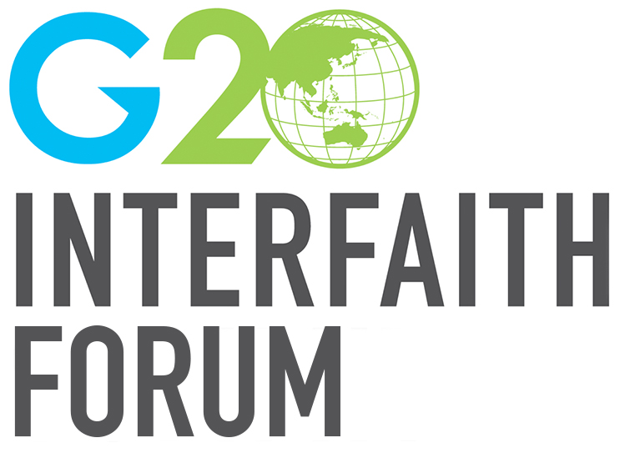
G20 Interfaith Forum
170 Kessels Road
Nathan, QLD 4111
Australia

www.g20interfaith.org
info@g20interfaith.org

+61 (0)7 3735 7052

Concept Paper for

G20 Interfaith Forum’s 2018 Initiatives

Based on the successful precedents of events organized in conjunction with prior G20 Summits since 2014, the G20 Interfaith Forum will hold a conference involving a broad array of universities, faith groups, academic experts and government officials as part of the lead up to this year’s G20 Summit in Buenos Aires, Argentina. (Information about prior Interfaith Forum events is available at the Association’s website, www.g20interfaith.org. A list of collaborating institutions involved thus far is provided below; additional collaborators are welcome.) The plan is to structure the organization’s major conference (to be held in Buenos Aires on September 26-28, 2018) and preliminary events so that they can contribute to the overall 2018 G20 process. The aim is to draw on interfaith insight and experience to develop recommendations regarding issues relevant to the priorities that the Argentine government has identified for this year’s G20 Summit.

Conference Title and Subthemes

The overarching theme for this year’s G20 Interfaith Forum is “Building Consensus for Fair and Sustainable Development: Religious Contributions for a Dignified Future.” In order to draw on the diverse backgrounds and interests of our various constituencies, a number of preliminary planning events will be held and the focus of the final event will be on a series of subthemes germane to the G20 Summit priorities, “the future of work” (including education for the future) and “a sustainable food future” (including issues of food security).

Specifically, we will organize a conference including an opening inaugural session, followed by two days of conference presentations and working group sessions aimed at developing concrete policy recommendations on the following subthemes:

Conference Subthemes:

- Religion, the Future of Work, and Social Protection
  - Accommodating Religion in the Workplace of the Future
  - Religious Perspectives on Innovation, Labor, and Education
  - Equalizing Opportunities for the Future
- Religion and a Sustainable Food Future
  - Religion and the Fight against Hunger
  - Food Security and Environmental Concerns
- Urgent Global Priorities
  - Religion, Refugees, and Migration
  - Protection of the Environment
  - Religious Perspectives on Countering Violent Extremism
  - Religious Contributions to Conflict Resolution
- Ethics, Economy and Sustainable Development
  - Religion, Good Governance and Sustainable Development
  - Sustainable Finance and Financial Inclusion
  - Structural inequalities and development
  - International Financial Architecture
  - Development of New Economies
  - Ethical Finance and Management of Faith Communities.

In each of these areas, the aim will be to convene expert working groups in advance of the Interfaith Forum itself to identify key issues and recommendations. Every effort will be made to emphasize issues and perspectives important to the Argentinean organizers. For example, we anticipate highlighting Latin American or developing world perspectives on the various subthemes. We will also take into account perspectives of indigenous peoples. The conference will explore alternatives to pure market systems and secular models of development, taking into account the richer perspectives on human development deriving from religious sources and exploring how these can be integrated synergistically with broader strategies for promoting resilience and enhancing the UN’s sustainable development goals.

The Interfaith Forum will also emphasize linkages between Argentinean priorities and other urgent global issues. Thus, while Argentina does not face a major refugee issue, it does face migration problems, and these are related issues about which religious voices have much to say. Similarly, issues regarding sustainable food supplies are inevitably linked to broader environmental issues. Providing opportunities for dignified labor holds the key to solving many of the problems of youth radicalization. In addition to exploring interfaith experience in dealing with radicalization of youth and resulting violence in the name of religion (education program, alternative forms of engagement, strategies for expanding youth employment, etc.), the conference will bring together youth leaders from various religious backgrounds to contribute insights. The foregoing subthemes are preliminary and are likely to be refined as a result of discussions emerging from the ongoing planning process).

In each of the foregoing areas, experts from a wide range of religious, national, and academic backgrounds will be brought together to raise the level of discourse on the relevant issues and to develop practical recommendations. Working groups are being commissioned to study particular issues and formulate concrete policy recommendations where religious voices are particularly well-positioned to make recommendations and to encourage implementation. The aim will be to explore ways that religious communities can assume responsibility and contribute distinctive ideas and solutions that can interact with and reinforce the efforts of public and civil society institutions.

Rationale: The impact of past Interfaith Forums has been acknowledged by G8 leaders in the past and G20 leaders of today. The Interfaith Forum will bring together experts on economy, law and politics, as well as global leaders from various religious, professional and humanitarian backgrounds to highlight the key role that religion plays in promoting aspects of achievement of the United Nation’s Sustainable Development Goals that Argentina has chosen to highlight during this year’s G20 Summit. Special attention will be paid to issues surrounding access to and quality of education, dignified employment, food security, the refugee crisis, addressing issues of religious extremism, conflict resolution, and other broader issues such as the environment, where religious voices have much to contribute.

Objective: The objective of the G20 Interfaith Forum is to facilitate peace and harmony between people of all religious and philosophical traditions while exploring ways to work together to strengthen human development understood in the broadest sense. This is important because religion plays a major role in global events today, but its role is complex and can easily be misunderstood or even overlooked as a factor on the global stage. By focusing on a series of concrete issues that are much in the public eye, we hope to suggest a variety of ways that religion can contribute practical policy recommendations that will lead to enhanced responses to crucial social challenges.

Participants: The annual G20 Interfaith Forum brings together opinion leaders such as political leaders, faith and interfaith leaders, experts and activists from around the world for three days of discussion and dialogue as a substantial contribution to the G20 Summit Process. Such a gathering showcases the scholarly and societal contributions of faith traditions and philosophies from around the world. Furthermore, this conference creates opportunities for communication and relationship building and raises the profile of participating communities, groups and organizations. Summary videos and programs of previous events can be viewed here.

G20 Interfaith Forum
Proposal

The program will be held in Buenos Aires from September 26-28, 2018. The program consists of an array of presentations drawing on leading expertise and global diversity. Based on increasing interest over the years, we are preparing for as many as 300, and possibly more participants and attendees in Argentina. While ties to the overall G20 process remain informal, the Argentinian G20 organizers have displayed a strong interest in the work emanating from the G20 Interfaith Forum initiatives, recognizing their potential for making a strong and independent internationally based contribution to the overall G20 process. As in past years, we anticipate organizing a small number of regional pre-Forum meetings that can feed recommendations into our final event and on to G20 leaders. This work will be further deepened by the work of focused working groups developing concrete policy recommendations regarding various G20 themes. We are happy to work closely and synergistically with other developing programs and engagement groups in the G20 process.

Tentative Schedule of Events

Day One:
- Inaugural Session with Political and Religious Leaders.
- Plenary addresses, panels, and working group sessions, with primary emphasis on general themes and labor related issues.
- Conference reception and keynote speakers

Day Two:
Plenary addresses, panels, and working group sessions, including presentations from leaders of major humanitarian organizations, continuing discussions from the perspective of religious leaders, legal scholars, economists and policymakers, emphasizing food security subthemes and other general G20 issues, as well as other themes that emerge from the preparatory process.

Day Three:
Panels and plenary addresses, allowing additional time for presentations from the perspective of civil society and faith community leaders. The focus will be on the major conference themes, but working groups may emerge on the following supplemental themes:

- Faith Perspectives on Addressing Socioeconomic Inequality
- The Ethics of Sustainable Development (religion and corporate compliance policies, social responsibility of entrepreneurs, etc.)
- Case Studies of Interfaith Dialogue and Synergistic Collaboration

Extracurricular programs:
- Specially arranged tours to important historic and religious sites in the area.
- Meetings with religious and governmental leaders.

Collaborating Institutions

- A Common Word Among the Youth (ACWAY), UK
- African Consortium for Law and Religion Studies
- Alliance of Civilizations Institute at Fatih Sultan Mehmet Vakif University, Turkey
- Amity Institute of Advanced Legal Studies, New Delhi, India
- Berkley Center for Religion, Peace and World Affairs, Georgetown University
- Brunel Law and Religion Research Group, UK
- Center on Religion, Law and Economy in the Mediterranean Area, Insubria University, Como, Italy
- Centre for Interfaith & Cultural Dialogue, Griffith University, Australia
- Center for Research and Training in Interfaith Relations, Morocco
- Consejo Argentino para la Libertad Religiosa (CALIR), Argentina
- Consorcio Latinoamericano de Libertad Religiosa
- Department of Law and Religion, Complutense University, Spain
- Institute for Policy, Advocacy, and Governance, Bangladesh
- International Consortium for Law and Religion Studies, Milan
- International Center for Law and Religion Studies, Brigham Young University, USA
- International Partnership on Religion and Sustainable Development (PaRD)
- International Religious Liberty Association
- KAICIID Centre for Interreligious and Intercultural Dialogue
- Ma’din Academy, India
- Max Planck Institute for Social Anthropology, Halle, Germany
- NALSAR (National Academy of Legal Studies and Research) University of Law, Hyderabad, India
- Oslo Coalition on Freedom of Religion or Belief, Norwegian Centre for Human Rights
- Oxford Society of Law and Religion, UK
- Regents College, Oxford University, UK
- Royal Academy of Jurisprudence and Legislation—Section on Law and Religion and Canon Law, Spain
- Sant’Edigio Community, Italy
- World Faiths Development Dialogue

Location: Palacio San Martin, Buenos Aires and local university venues.

The annual G20 Interfaith Forums have attracted increasing numbers of government, academic and interfaith leaders. For information on these events, see our website of past Forums here. This site contains leads to the official web pages for past Interfaith Forums that include programs, speakers, videos of many of the conference speakers, and so forth.

