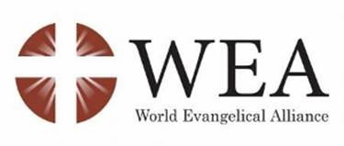
HOW CAN SOCIAL COHESION BE ACHIEVED IN THE CENTRAL AFRICAN REPUBLIC?
The Role of Local And Religious Communities To Reinforce The Rule Of Law
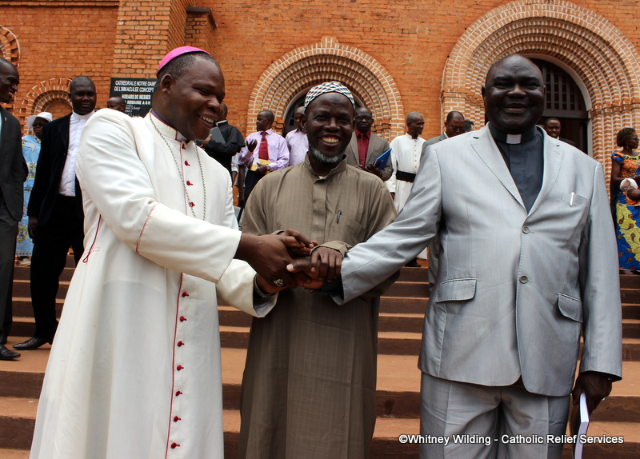
20 March 2018
Palais des Nations, Geneva
15:00 – 16:30 Room XXIII

Ms. Marie-Thérèse Keita-Bocoum Independent Expert on the human rights situation in the Central African Republic

H.E. Cardinal Dieudonné Nzapalainga President of Caritas Centrafrique and member of the interreligious peace platform

H.E. Imam Oumar Kobine Layama President of the Islamic Conference in CAR, member of the interreligious peace platform

Rev. François Ndeckere Pasteur, representative of the CAR Evangelical Alliance

H.E. Archbishop Ivan Jurkovič Permanent Observer of the Holy See

H.E. Ambassador Nassima Baghli Permanent Observer of the Organisation of the Islamic Conference (OIC)

Moderator : Catherine Fiankan-Bokonga, Vice-President Swiss Press Club

Interpretation English / French

Five years after the near collapse of the Central African Republic in 2013, the country still has a long way to achieve security, peace and reconciliation. The State and the MINUSCA cannot cope with the criminalized gangs who ravage the communities and continue to instill fear in order to exploit the resources of the land.
In a country where parties to the conflict have continuously tried to steer enmity along ethnic and religious lines, the role of religious leaders is of particular importance. In this context, the CAR has seen a remarkable initiative in the form of the Interfaith Peace Platform. The participation of civil society and religious communities in the Bangui Forum has reassured terrorized citizens and served as a basis to the successful elections that followed.
This has made the Independent Expert on the human rights situation in the CAR call, several times, for more effort on social cohesion and social contract during her reports to the Human Rights Council. The event is designated to support this call and contribute to understanding what it entails.

