UNAIDS Community Support Department Update for Faith-Based Organizations responding to HIV- fbo uPdate.

This is a short update on some of the engagement by faith-based organizations on HIV. Please do forward this update to your colleagues and other interested friends. Anyone wishing to be included in the mailing list, or wanting to include an item for circulation should send an e-mail to Julienne Munyaneza [jmunyaneza@gmail.com](mailto:jmunyaneza@gmail.com) with a copy to Sally Smith [smiths@unaids.org](mailto:smiths@unaids.org).

Do follow us on social media: Twitter: @SallyLynnSmith and Facebook: [civil society dialogue space](https://www.facebook.com/groups/756699207756802/)

***Highlights***

Please note that UNAIDS work with faith-based partners is much broader than the initiatives included in this update especially at country and regional level. However, given the brevity of this report and the uniqueness of this new initiative, this update focuses on the UNAIDS-PEPFAR FBO Initiative[1] as a collaborative partnership from which some important lessons can be drawn. The update covers the period from **June 2017 to February 2018**.

Further details of activities from this period can be found in the web-links on both UNAIDS and FBO partner websites listed at the end of this article. Some brief highlights are included here to give you a flavour of the work:

**Consultations on scaling up "Early Diagnosis and Treatment for HIV-positive Children" led by Caritas Internationalis in collaboration with PEPFAR, UNAIDS and other partners.**

As a follow-up to a series of meetings in 2016 and early 2017 to scale up access to HIV medicines for children, Caritas Internationalis led on the convening of two further consultations. Firstly, a regional consultation brought together representatives from 3 different countries including Nigeria, the host country, DRC and Zimbabwe, as well as other participants from the region in June 2017. The purpose of this consultation was to develop skeleton action plans to strengthen the engagement of faith-based organizations in national action to scale up access to HIV medications for children.



*Luiz Loures, UNAIDS Deputy Executive Director, John Onaiyekan, Archbishop of Abuja, among participants at the Abuja Consultation co-organized by Caritas Internationalis, PEPFAR & UNAIDS, June 2017 (Photo Caritas Nigeria)*

This was followed by a consultation with representatives from Pharmaceutical and diagnostic companies at the Vatican in Rome in November 2017. The second consultation brought together leaders of major pharmaceutical and medical technology companies, multilateral organizations, donors, governments and organizations providing or supporting services for children living with HIV for a high-level dialogue. The participants made proposals to speed up the research, development, approval, introduction and uptake of medicines and formulations for infants, children and adolescents. These included steps to make priority medicines in the pipeline quickly available in the short term and innovative mechanisms to facilitate and accelerate the development of paediatric formulations for HIV and other life-threatening diseases over the longer term.

**The Interfaith Prayer Breakfast 13 September 2017**

The World Council of Churches Ecumenical Advocacy Alliance WCC-EAA led on convening of a prayer breakfast in September 2017 on the side-lines of the UN General Assembly in New York, which brought together over 100 Religious Leaders and other leaders on the theme ‘Faith on the Fast Track’. A prayer breakfast will be organised again by WCC-EAA, PEPFAR & UNAIDS in NYC on September 27th, 2018. The prayer breakfast in 2018 will focus on TB and HIV in children and adolescents. Please contact to Julienne Munyaneza [jmunyaneza@gmail.com](mailto:jmunyaneza@gmail.com) for further information as **this event is by invitation only**.

**Regional consultations to address faith-only healing:**

The World Council of Churches Ecumenical HIV and AIDS Initiatives and Advocacy (WCC-EHAIA) led on the convening of two regional consultations in Kampala, Uganda and Kigali, Rwanda in September 2017. Among the expected long-term outcomes of these important consultations are two manuals on capacity building for people living with HIV and faith leaders on treatment adherence and advocacy on positive use of faith in HIV response (in French and English); and to inspire a counter-movement against ‘faith-healing only’, led by faith communities in each country represented.

**New data published**

For the first-time national level data on health service delivery by FBOs in Kenya has been disaggregated to facility level and service data for all faith-based facilities in each county. This data collection and analysis was led by the Academic consortium of the initiative and has been made available on a web platform (<http://ihpemory.org/kenya-overview/>) for outside users. The findings have been written up and submitted to the peer-reviewed journal ‘Development in Practice’ by the lead partners.

**Faith-based health service (FBHS) providers strengthened**

A mentorship program was established by the African Christian Health Associations Platform (ACHAP), where younger or weaker national health associations are mentored by more established, stronger ones in the same region. Mentoring exchange visits were undertaken between two pairs of networks and other mentoring partnerships between partner countries are already underway in 2018.

**1500 religious leaders and hundreds of adolescents tested for HIV**

Over 1500 religious leaders from different faith traditions have taken the HIV test and publicly encouraged their faithful to follow the example as part of the World Council of Churches ‘Leading by Example Campaign. Awareness raising activities in preparation of celebrating the Day of the African Child in Nairobi led to 550 adolescents, young people and religious leaders getting tested. A call to action was issued at the end of meeting: <http://www.oikoumene.org/en/resources/documents/wcc-programmes/diakonia/eaa/live-the-promise/act-now-for-children-and-adolescents-living-with-hiv-1>.

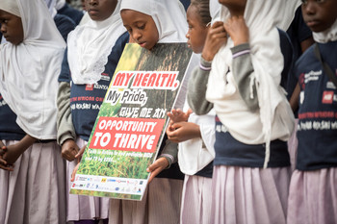

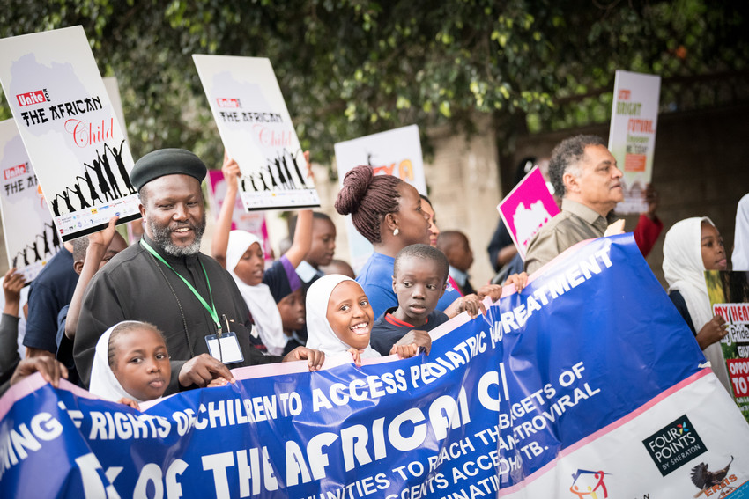

*Commemoration of the Day of the African Child in Nairobi, Kenya -16 June 2017- focused on the rights of children and adolescents living with HIV (photo Albin Hillert/WCC).*

**Challenges:**

In late 2016 Michel Sidibe identified both opportunities and challenges to the international community, working in partnership with FBOs on the SDG’s:

‘*The SDGs provide a range of opportunities for FBOs to engage. There are many areas of potential synergy, especially in delivering holistic health services. This growing interest from international organizations to build partnerships with FBOs has made for a crowded and growing field, but it is also a mine-field. The influence of religion in areas such as sexual and reproductive health, gender equality, and in situations of conflict and crisis can be both extremely positive and profoundly negative. It is important that in the rush to leverage new faith-based partnerships, international partners draw on the wisdom and experience that already exists within the UN system —and in particular the IATF —rather than pushing ahead with naïve enthusiasm. Rushing in where angels fear to tread can make sensitive and explosive issues and situations worse*’.

He urged readers of the special edition to address these three specific challenges:

* Finding a way forward together, rising above ideological differences to eliminate sexual violence and address the needs of adolescent girls so that they can take control of their own sexual and reproductive health and to be able to decide when and who they marry, when and how many children to have, and how to protect themselves from HIV infection.
* Harnessing the positive power of religious faith to turn back the tide of religious extremism that fuels violent conflict and drives stigma and discrimination.
* Findings ways to partner more effectively with the health and educational infrastructure managed by religious bodies and their vast community networks.

(Michel Sidibe Sept 2016. <http://bit.ly/2cvMzSM>)

**Lessons Learned:**

UNAIDS has worked in 2016/7 through the PEPFAR/UNAIDS partnership initiative in the five focus areas and has learned several important lessons that echo the words of Michel Sidibe in his editorial to the special edition.

* The principles of country ownership and leadership, respect for human rights and gender equality, working across a broad spectrum of faith traditions and the UN inter-agency task force on faith and development (IATF) criteria for engagement with FBOs in the SDGs are important to guide future initiatives.
* Activities should be closely aligned with national plans and priorities. UNAIDS (both the Secretariat and its Co-sponsors) play a critical role at national level, to reflect the principals of inclusiveness and equity; lead the development of faith engagement plans and a support the development of a strong interfaith networks at national level.
* Through partnership initiatives as the UNAIDS/PEPFAR FBO Initiative, funds should be directed to interfaith country-led work as an important balance to work with global partners. In addition, mechanisms such as the national FBO action plans described above, should be explored as ways to mainstream this work into existing national funding streams for HIV.

**Current and Forthcoming Events**

* In the context of the PEPFAR/UNAIDS Initiative, UNAIDS is supporting national AIDS authorities to host four country consultations in March 2018, in Zimbabwe, Nigeria, Tanzania and DRC respectively. The aim of these consultations is to develop national FBO HIV/AIDS Response Action Plans in line with national AIDS plans (these will build on the preliminary work conducted around access to paediatric HIV treatment started in Abuja-and broaden out to address other areas of the national response). A more comprehensive report will be provided in the next update.
* Strategic Learning Exchange- is taking place in Amman Jordan in March 2018.
* International AIDS Conference (IAC), Amsterdam, July 20-28, 2018, there will be a range of activities for faith partners including a faith networking zone, faith pre-conferences, and an interfaith service. For additional information please see
* <https://www.oikoumene.org/en/what-we-do/eaa/live-the-promise-hiv-campaign/activity_events>

***Resources/Publications:***

* Sidibé, Michel. 2016. "Religion and Sustainable Development." *The Review of Faith & International Affairs* 14 (3)

<http://www.tandfonline.com/doi/full/10.1080/15570274.2016.1215848>

* Olivier, Jill, and Sally Smith. 2016. "Innovative faith-community responses to HIV and AIDS: Summative lessons from over two decades of work." *The Review of Faith & International Affairs* 14 (3):5-21.

http://www.tandfonline.com/doi/abs/10.1080/15570274.2016.1215839?journalCode=rfia20

* Blevins, John, Mimi Kiser, Emily Lemon, and Ahoua Kone. 2017. "The percentage of HIV treatment and prevention services in Kenya provided by faith-based health providers." Development in Practice 27 (5): 646-657. <http://www.tandfonline.com/doi/full/10.1080/09614524.2017.1327027>
* High-level discussion to scale up HIV diagnosis and treatment for children and adolescents 17 November 2017 <http://www.unaids.org/en/resources/presscentre/featurestories/2017/november/20171117_vatican> Action Plan <http://www.pedaids.org/page/-/Rome_Action_Plan_2017.pdf> .
* *Academic Consortium web platform of health FBO service delivery in Kenya:* <http://ihpemory.org/kenya-overview/>
* Lead by Example Religious Leaders HIV Testing campaign webpage  
  <http://www.oikoumene.org/en/what-we-do/religious-leaders-and-hiv-testing>
* Nairobi, Kenya Framework for Dialogue Impact Assessment 7th-8th February 2017: <http://www.oikoumene.org/en/press-centre/news/gathering-in-kenya-explores-eliminating-hiv-stigma-through-love-and-dialogue>
* Abuja, Nigeria Consultation June 2017: <http://www.unaids.org/en/resources/presscentre/featurestories/2017/june/20170619_nigeria>
* Nairobi, Kenya ‘Day of the African Child’ event 16th June 2017:
* <http://www.oikoumene.org/en/press-centre/news/day-of-the-african-child-an-opportunity-to-raise-awareness-on-pediatric-aids>   
  <http://www.oikoumene.org/en/press-centre/news/201dit2019s-time-to-take-action201d-2013-201dlet2019s-make-this-virus-powerless201d>
* Kampala, Uganda Faith Healing Consultation 4th-8th September 2017:

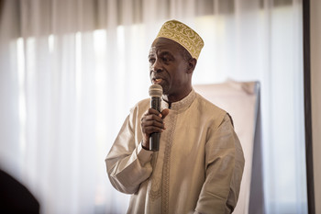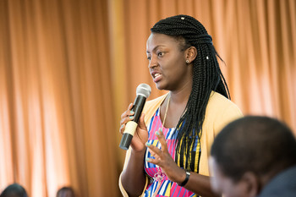

*Participants included faith leaders and young people from all religions and young people ((photo Albin Hillert/WCC).*

<https://www.oikoumene.org/en/press-centre/news/201cfacing-the-storm-of-hiv-we-can-move-together-be-agents-of-change201d>   
<https://www.oikoumene.org/en/press-centre/news/four-voices-one-concern-2013-addressing-201cfaith-healing-only201d-in-context-of-hiv>

* New York, USA Interfaith Prayer Service 12th September 2017:  
  <http://www.oikoumene.org/en/press-centre/news/it-will-take-faith-to-get-down-to-business-to-overcome-hiv-and-aids>
* New York, USA Prayer Breakfast 13th September 2017: <http://www.unaids.org/en/resources/presscentre/featurestories/2017/september/20170914_faith_fasttrack>  
  <https://www.oikoumene.org/en/press-centre/news/faith-on-the-fast-track-for-children-living-with-hiv>
* Kigali, Rwanda consultation on HIV Treatment Adherence and Faith Healing 25th-28th September 2017:  
  <https://www.oikoumene.org/en/press-centre/news/building-momentum-as-wcc-ehaia-addresses-faith-healing-only-practices-in-francophone-africa>
* The Ecumenical Pharmaceutical Network based in Kenya, EPN in cooperation with UNAIDS Kenya launched an online course on paediatric HIV  <http://epnetwork.org/elearning/course/online-pediatric-hiv-course/>

***Other***

* Ending child marriage: The African Committee of Experts on the Rights and Welfare of the Child and the African Commission on Human and Peoples’ Rights have jointly issued a General Comment on ending child marriage in Africa. This provides guidance to states on their obligations to end child marriage under the main regional treaties. More info and the General Comment available in English and French here: <http://www.acerwc.org/acerwc-and-achpr-adopt-their-first-ever-joint-general-comment/>.
* Sexuality Education: A revised International Technical Guidance on Sexuality Education released by UNAIDS and UNESCO: <http://www.unaids.org/sites/default/files/media_asset/ITGSE_en.pdf>; <http://www.geastudy.org/publications/>; <https://theconversation.com/african-boys-and-girls-enter-teens-with-gender-stereotypes-firmly-set-84501>.

1. The UNAIDS-PEPFAR Faith Initiative is a partnership that was developed in 2016 as a time limited pilot programme intended to strengthen partnerships with Faith Based Organizations (FBOs) globally and in up to six PEPFAR and UNAIDS priority countries in response to some of the challenges laid out in the Lancet special edition on faith and health care in 2015. Operational through 2016-2018, the initiative is planned in two separate phases: Phase I ran from April 2016 - September 2017 and Phase II began in November 2017.

   The countries selected for Phase I were Kenya and Zambia. UNAIDS worked with five global FBO implementing partners on a series of global, regional and country level activities under this initiative in the five focus areas:

   1. Strengthen FBO leadership and advocacy for the Fast-Track approach
   2. Collect, analyse and disseminate data on health care services provided by faith-based health service providers (FBHS)
   3. Address stigma and discrimination in communities and health care settings
   4. Create demand for service uptake and retention in care
   5. Strengthen HIV and AIDS related service provision

  