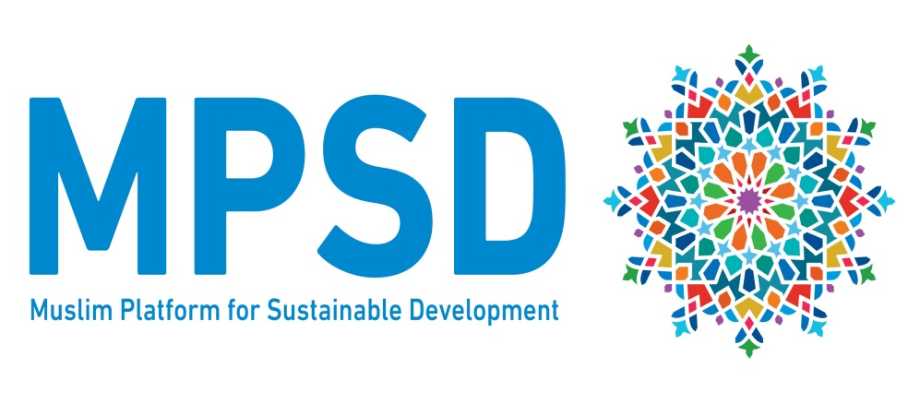

www.muslimplatformsd.org (Goes live by March 7th)

About Us
The Muslim Platform for Sustainable Development (MPSD) is an online knowledge hub that enables users to play a constructive and contributory role in achieving the United Nations’ 2030 agenda for Sustainable Development.
Faith based agencies and organisations play a critical role in responding to development issues and mobilising resources to alleviate poverty. The MPSD will enable organisations to collate and disseminate resources and information as well as facilitate cross organisational cooperation in constructing a distinct Muslim understanding of and approach to the Sustainable Development Goals.

Objectives
The main objectives of this platform are to ensure:
- Ensure representation of the Muslim voice by advocating at a global, regional and national level while ensuring governments are held accountable
- Engage in clarifying and agreeing discourse, including conducting collaborative research, to provide informed Islamic faith-based positions.
- Build capacity and mobilise for engagement in Agenda 2030 planning and implementation at national and global level, ensuring accountability to citizens and civil society.
- Joint learning on humanitarian and development methodology and approaches

What has happened so far?
The MPSD has conducted a series of regional consultative meetings- in Asia, Middle East & North Africa, Africa and Europe - with other local and national NGOs/CSOs around the world. The purpose of these meetings was to explore the challenges of engagement on the UN 2030 Agenda, priorities for engagement and possible aims, structures and modes of operation for this online platform initiative.

In November 2016 MPSD was formally formed with a Global Steering Committee elected from the four regions. Work is now commencing on forming the knowledge hubs which will work on agreeing research and development of discourse.

How we work
The MPSD achieves its goals by undertaking the following activities:

- Building a global knowledge base
The MPSD through its members, will share and develop useful resources and conduct research with the aim of disseminating and sharing best practice and discourse in the field of international development that is rooted Islamic values and teachings.
Knowledge Hubs are being developed in the following priority areas:
- Poverty reduction and food security
- Education
- Climate Change
- Economic Growth
- Gender Justice
- Support for the Family as an institution
- Health

- Providing a platform for engagement and representation
MPSD will bring together Muslim stakeholders from around the world to engage with the United Nations’ 2030 agenda for Sustainable Development at both a national, regional and global level to achieve the 17 SDGs and ensure representation within the various networks and forums involved in implementation and influencing.

- Developing regional knowledge networks and communities of practice
The MPSD will act as a platform for facilitating dialogue, capacity building and networking amongst its members. Our website and activities will act as a portal for assisting users to collaborate and contribute to national development planning and create long lasting development partnerships with FBOs.

Members
Current members of the platform
Asia:
- HelpingHands
- Islamic Relief India
- Universiti Sains Malaysia
- Asia Muslim Action Network

Europe:
- Islamic Relief Worldwide
- Islamic Relief Academy
- Human Appeal International
- Durham University
- IFEES
- MADE
- Global One
- FEMYSO

Middle East:
- Al-Hiden
- RAF
- IHH
- Jazair Alkhair

Africa:
- Uganda Muslim Supreme Council
- IGCEI
- SANZAF
- Global One

