AnNual Report
JOINT LEARNING INITIATIVE ON FAITH & LOCAL COMMUNITIES
2016
Table of Contents
Message from Our Board Co-Chairs 3
Coordinator’s Perspective 4
Section I: About JLI 7
Section II: Governance 10
Board Members 11
Advisory Group 12
Progress Against JLI Operating Plan (2016-2018) Error! Bookmark not defined.
Goal 1. Gather knowledge about the activities & contributions of faith groups and synthesize into useful outputs through LH Error! Bookmark not defined.
Goal 2. Connect policy makers, practitioners, and academics with the knowledge, resources, and expertise, with particular responsiveness to their wants and needs, to understand the activity and contribution of faith communities Error! Bookmark not defined.
Goal 3. Support broader global initiatives to catalyze the understanding the contribution & activity of faith groups Error! Bookmark not defined.
Goal 4. Improve accountability and governance Error! Bookmark not defined.
Goal 5. Ensure JLI’s growth and sustainability Error! Bookmark not defined.
Financial Report 24
Collaborations 26
Communications Activities 28
Newsletters 28
Social Media Baseline Engagement 29
JLI Website 29
JLI Website Analytics Report 30
Annex I: LH Updates 31
Annex II: Detailed Web Analytics Report 34
Annex III: Timeline 37
Annex IV: Financial Report 43

Message from JLI Board Co-Chairs
Dear JLI Community,
The JLI is working in challenging times. The need for the fullest possible engagement of local faith networks is acute and vast. We are seeing a pragmatic new opening in the secular world to the possibility of greater collaboration with local religious and faith groups. How can we work together to scale up?

The JLI’s goal is to support the fullest possible engagement of faith groups —religious leaders and local faith communities, and faith–based organizations—in meeting the needs of people who are displaced, marginalized, impoverished and victims of conflict and violence. JLI’s strategy focuses on gathering and communicating the best evidence for the capacities, activities and contributions of local faith groups to policy and decision makers and to practitioners, to support effective, scaled up partnerships between public sector and secular bodies and faith groups. Our tactics include joint learning through thematically focused Learning Hubs, dissemination of evidence through social media, briefs, publications, convenings and conferences, and close engagement with policy and decision makers.

Last October, the JLI leadership took stock of its progress since it’s founding in 2012. We appreciated the achievements of the volunteer Learning Hub co-chairs and members in developing and communicating evidence materials, encouraging gap-filling research and engaging with policymakers. We celebrated the Religion and Sustainable Development conference held at the World Bank, July 2015. Here, we brought forward the best of the evidence for faith activity and impact to policy makers and secular actors, and launched the Lancet Series on Faith-based health care delivery. The Board decided to continue the JLI project for a defined 3-year term, to expand and strengthen our governance, to focus our work on effective communication of evidence to decision makers and expand our financial resources.

As the Coordinator's report details, we have made good progress on the goals we set, and the activities we agreed in our 2016 operating plan.

We are indebted to the JLI Coordinator who, working part time, has steadfastly supported this work since its inception, and has ensured our tiny budget continues to take us a long, long way.

Many thanks to the now retired Steering Committee, and welcome to our wonderful new Board and Advisory Group.

Matthew Frost Rob Kilpatrick
Co-Chairs, Joint Learning Initiative on Faith & Local Communities

Coordinator’s Perspective
Assembling the JLI timeline since our founding in 2012 was an informative experience (see annex III)! Thanks to the committed leadership of the Learning Hub Co-Chairs and the vision and unwavering energy of the Steering Committee, we have accomplished a lot over four years, with very limited resources. Together we have focused attention on the necessity and availability of evidence for faith groups’ activities and contributions—what’s available and what is missing. Together we have built joint learning communities that have resulted not only in excellent scoping reports and briefs, but have also created friendship and countless new partnerships, enhancing research and practice. Together we have publicized ‘what works’ in national, regional and international fora, and reputable journals. JLI is now a recognized champion for evidence-based decision making for full engagement of religious and faith-based networks in development and humanitarian response. Working together, JLI has helped move the discussion in policy circles from ‘whether’ to engage with faith groups to ‘how’.

2016 has been a big year for JLI!
- 3 Learning Hubs collaborated to deliver to the World Humanitarian Summit, 5 Evidence briefs on the roles of Religions and FBOs in humanitarian response, the new Peace and Conflict Hub’s Scoping Report, and a well-attended side event with case studies illustrating the briefs
- We have a 32-member spectacular new Board, incorporating many of the founding visionaries, as well as key leaders of important global and local religious and faith-based organizations (FBOs), and academic experts.
- With a grant from the GHR Foundation, JLI brought on its first full time Knowledge Manager, to increase support to Learning Hubs, and to synthesize and better communicate evidence
- The Refugees and Forced Migration Learning Hub launched, with guidance from the retiring Resilience Hub leaders
- The Mobilisation of Local Faith Communities Learning Hub revived the formerly Capacity Building Learning Hub
- With coaching from Oxfam USA and other members’ communications and advocacy teams, JLI is improving its evidence translation and shaping a new communications plan to more effectively digest and deliver key messages to decision makers

JLI progress against goals
JLI has progressed well against the 5 goals set out for 2016 in the Operating Plan (for a detailed report on progress for each goal and objective)

- We advanced knowledge gathering and outputs, by launching a new hubs, and focusing support on 4 active Hubs
- We laid good groundwork towards more effectively connecting with policy makers practitioners and academics
- We are present and visible as an ‘evidence focal point’ in global initiatives to support fuller engagement of faith groups
- We overhauled our governance and accountability structures
- We successfully grew JLI’s financial base through fundraising
But it’s very clear to me that JLI is just beginning! And in view of the scale and urgency of the needs addressed by religious and faith-based groups, we need to hurry up! Our evidence needs to be more rigorous and better communicated; we need to grow and mobilize our exceptional network. Through partnerships, we need to collaborate more effectively with centers of academic excellence and with faith networks at the local level that are delivering hope and real change for people in need.

JLI’s challenges
- How do we engage, equip and mobilize our talented Board and Advisory Group to effectively communicate with key decision makers?
- How do we deliver more value to institutional and ordinary members, with useful news and knowledge, well-packaged communications tools, and unique opportunities to forge new collaborations across faith and sectoral lines?
- How do we increase a sense of institutional ownership of JLI among member institutions as evidenced by sharing of members’ own evaluations and case studies on the JLI website, in-house briefings for colleagues, incorporation of JLI messaging into institutional positioning as a faith-based organization?
- How do we engage more fully with partners in the global south and at the national level?
- How do we partner with centers of academic excellence, and intermediary organizations like PaRD to leverage strengths and avoid duplication of effort?
- How do we focus more on the ‘how’ to engage –with better information on ‘what works?’ including mechanisms and methods for scalable replicable engagement with local faith groups?
- How do we focus our work to do the most fruitful things well, keep our leadership engaged productively and our small team healthy and motivated?

As we look back on this year, we have much to be thankful for:
  - Our team of brilliant freelancers and interns including Alex Daniels, Jasmine Lee Wong, Andrea Arzaba, Olivia Wilkinson and most especially Helena Manguerra whose exemplary work supported so much of our recent progress
  - Ben Clowney and his Hands Up web management team
  - Learning Hub Co-chairs for their inspiration, excellence and generous gifts of time to the joint learning process —especially Alastair Ager and Helen Stawski retiring after 4 years with the Resilience LH, who set a high standard for the joint learning process and have been generous in sharing with other Hub chairs
  - McKinsey and Co team under John Drew’s leadership for their faithful accompaniment
  - The confidence of our institutional members as expressed in their generous supporting contributions
  - Wise guidance and encouragement from Matthew Frost and Rob Kilpatrick, and all our Directors

It remains a privilege to serve JLI as part-time Coordinator, and a complete joy to see the time and talent of so many diverse people combine to raise the profile and credibility of religious and faith based organizations as effective partners in urgent humanitarian and development work.

Buíochas le Día!

Jean Duff Washington DC
Coordinator, JLI March 2017

Section I: About JLI
An international collaboration on evidence for faith groups’ activity and contribution to community health and wellbeing.

JLI was formed in 2012, and initially funded, by a broad collaboration of international development organizations, UN agencies, academic institutions and faith groups. This group was drawn together by a single shared conviction: the urgent need to build our collective understanding of the potential of local faith communities for improving community health and well being.

Our Vision: Full and appropriate engagement of capacities of faith-based groups in the achievement of the SDGs through effective partnerships with public sector and secular entities, as well as among religious groups themselves.

Our Approach
- Build cross-sector, multi-religious, interdisciplinary, collaborative learning platforms to gather robust evidence for capacities, activities and contributions of faith groups
- Understand the drivers of attitude and behavior change for policy makers and practitioners re engaging with faith groups
- Deliver smart communication to policymakers and practitioners transform the quality, effectiveness, and impact of partnerships between faith groups and the development community

Our Goals
Overarching Goal: Increase engagement of faith groups in development and humanitarian response

- Gather knowledge about the activities and contributions of faith groups through Learning Hubs and synthesize into useful outputs
- Connect policy makers, practitioners and academics with the knowledge, resources and expertise they want and need, to understand the activity and contribution of faith groups
- Support global and national initiatives to catalyse the understanding of the contribution and activity of faith groups
- Improve JLI’s accountability and governance
- Ensure JLI’s growth and sustainability

JLI Organization and Functional Structure
JLI is an unincorporated project, operating under the fiscal sponsorship of the Center for Faith and the Common good, a US tax exempt corporation. The small JLI secretariat supports joint learning and effective communication by its Board, Advisory Group, and Learning Hubs. The Knowledge Manager supports the gathering and exchange of evidence through the Learning Hubs, oversees the synthesis and communication of information through the JLI website, policy briefs, scoping papers and other outputs and supports JLI Leadership. The Coordinator manages the project, creates platforms and builds networks for dissemination, mobilizes and equips JLI Leadership for effective communication with decision makers, supports partnerships with centers of excellence for evidence, and grows the JLI membership. The Executive Committee, Board and Advisory Group provide oversight, and leadership on outreach to key decision makers in humanitarian and development entities.

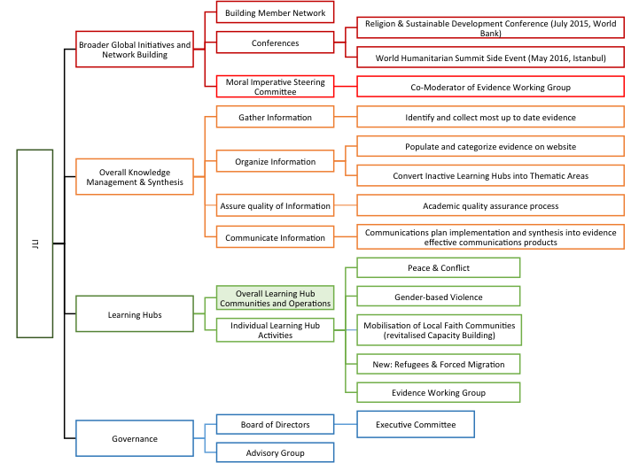

Our Learning Hubs
JLI works carries out its work through Learning Hubs organized around thematic areas and led by volunteer experts from academia, policy and practice. Learning Hubs ask the questions:
- What do we know about faith groups’ capacities, activities and contributions to specific development and humanitarian efforts?
- How can we better communicate that knowledge?
- What are key gaps in knowledge for further research?

Learning Hubs have lifecycles, usually completing their work in a few years. The work of the Inactive Hubs is available through “thematic areas” on the website.

Hubs | Co-Chairs, Affiliations
Sexual & Gender-based Violence (GBV)  (98 Members) | Veena O’Sullivan, Tearfund (Secretary)  Elizabeth Dartnall, SVRI  Diana Arango, World Bank Group
Mobilisation of Local Faith Communities (formerly Capacity Building) | Christo Greyling, World Vision International  Catriona Dejean, Tearfund  Academic chair, TBD
Peace & Conflict  (130 Members) | Lucy V. Salek (Moore), Islamic Relief Worldwide  Sarah Pickwick, World Vision  Alpaslan Ozerdem, Coventry University
Refugees & Forced Migration  (68 Members) | Sadia Kidwai, Islamic Relief Worldwide  Elena Fiddian-Qasmiyeh, University College London
Resilience (Inactive as of Summer 2016) | Alastair Ager, Queen Mary University and Columbia University  Helen Stawski, Islamic Relief Worldwide
Evidence Working Group (30 members) | Jean Duff, Partnership for Faith and Development and JLI  Dean Pallant, Salvation Army

JLI Members

Below, we outline benefits of membership and participation. We integrated the membership process so that interested persons can select which hubs to join when they sign up for the newsletter and register to become a member.

Individuals – Levels of Participation |  | Benefits
Level A | No formal affiliation with JLI | View publicly available event calendar, resources and news posts on the JLI website. Submit resources and news posts
Level B | JLI Email Updates and Newsletter Recipient | Receive JLI Newsletters (4 per year) and periodic website resource emails
Level C | JLI Members | - Posts a JLI member profile  - Access to all Hub Resources  - Access to and eligible to be listed in JLI member network directory  - Affiliate with resources and organizations  Leaning Hub Members  - participate in LHs  - receive LH communications  - Invited to suggest organizations and projects for resources and addition to LHs  - Equipped with Hub briefs and support for advocacy
* Benefits are cumulative. Higher levels of participation retain benefits from previous level

Section II: Governance
The JLI Board is co-chaired by Matthew Frost and Rob Kilpatrick. Following the direction of the Steering Committee, the JLI has restructured its governance to now include an Executive Committee an expanded Board of Directors, as well as Advisory Group.

The Executive Committee meets bi-monthly by telephone with one in-person meeting per year, attended as possible. Responsibilities include: Oversee JLI progress against operating goals and budget; represent JLI at high level meetings; promote JLI and serve as spokesperson; share evidence from own network and collaborate on evidence gathering; communication and promotion of JLI outputs within own networks; active support for fundraising for JLI.

The Board of Directors meets three times annually, twice by teleconference, and with one meeting per year attended in person, as possible. Responsibilities include: Oversight of JLI progress against goals; budget oversight; active participant in fundraising; share evidence from own networks; collaborate with JLI on evidence gathering, and communication; facilitate meetings with key decision makers, and disseminate JLI outputs to own networks Active support as needed to JLI Coordinator

The Advisory Group meets once a year to overlap with Board meeting, and in-person as able. Responsibilities include: share evidence from own networks; collaborate with JLI on evidence gathering, and communication; facilitate meetings with key decision makers, and disseminate JLI outputs to own networks

From 2012-2016, JLI was an unincorporated project hosted by Tearfund UK. Tearfund lent its charitable status to JLI operations, and serves as it fiscal agent. In view of JLI’s growth, currency conversion challenges and donor requirements relating to fiscal sponsorship, JLI Board approved moving the project to a tax-exempt platform in the US, the Center for Faith and the Common Good.

Staff: Jean Duff serves as part-time Coordinator, and Stacy Nam as full-time Knowledge Manager. The JLI is supported as needed by a team of dedicated freelance workers, technical experts and paid interns.

JLI Board Members

Name | Affiliation
*Matthew Frost | Co-chair, the Joint Learning Initiative on Faith & Local Communities and Pilgramway
*Rob Kilpatrick | Co-chair, the Joint Learning Initiative on Faith & Local Communities, Traidmission and Smallternative
John Nduna | ACT Alliance
Jonathan Duffy | Adventist Development & Relief Agency
Ruth Messinger | American Jewish World Service
Rachel Carnegie | Anglican Alliance
Rebeca Rios-Kohn | Arigatou International
Benjamin Laniado | Cadena
Kate Bingley | Christian Aid
John Blevins | Emory University
* Rob Radtke | Episcopal Relief & Development
Lucas Koach | Food for the Hungry
Katherine Marshall | Georgetown University
Tomy Hendrajati | Humanitarian Forum Indonesia
Rick Santos | IMA World Health
Imrana A. Umar | International Interfaith Peace Corps
Anwar Khan | Islamic Relief USA
* Muhtari Aminu-Kano | Islamic Relief Worldwide
Mohammed Abu-Nimer | King Abdullah bin Abdulaziz International Centre for Interreligious and Intercultural Dialogue (KAICIID)
John Drew | McKinsey & Company
Ray Offenheiser | Oxfam America
* Jean Duff | Partnership for Faith & Development
Amjad Saleem | Paths2People
*Ian Causebrook | Tearfund
Dean Pallant | The Salvation Army
Ayesha Chaudhry | University of British Columbia
* Jill Olivier | University of Cape Town
Julie Clague | University of Glasgow
David Boan | Wheaton College
Christine MacMillan | World Evangelical Alliance
* Charles Owubah | World Vision International
*denotes Executive Committee Member

Advisory Group

Name | Affiliation
Mike Battcock | DFID
Jørn Lemvik | Digni
Thomas Lawo | International Partnership on Religion & Development
Christopher Blackham | Samaritan's Purse
Vinya Ariyaratne | Sarvodaya
Nobuyuki Asai | Soka Gokkai International
Christoph Benn | The Global Fund
Sally Smith | UNAIDS
Caroline Lensing-Hebben | UNDP
Azza Karam | UNFPA
Mark Brinkmoeller | USAID
Adam Taylor | World Bank Group

JLI Operating Plan 2016-2018

JLI Operating Goal 1:
Gather knowledge about the activities, role, contributions and challenges of faith groups through Learning Hubs

Objectives |  | 2016 Progress | 2017 Goals |  | 2018
1.1: Organize, coordinate and resource experts and LH members to aggregate, synthesize and deepen thematic knowledge through existing Learning Hubs (LHs)
 | Resilience: World Humanitarian Summit Evidence Collation & Leading Production of 5 WHS Policy Briefs. Completed Resilience Hub work after 4 years. Thanks to Alastair Ager and Helen Stawski! |  | See 1.5 below
 | - Peace & Conflict (P&C): Completed Scoping Study & WHS Policy Brief  - Sexual & Gender-based Violence (GBV): WHS Policy Brief Completed in May 2016  - Refugee and Forced Migration Hub TOR agreed, launched July 2016 and met in-person 9/21 |  | Develop 2017 work plan for each active LH; update LH TOR as needed  - P&C LH establish 2 sub working groups  - GBV new DFID funded scoping study on religion and harmful practices for girls; presentations at SVRI meeting and at October 2017 Forum; develop Hub Secretariat hosted by Tearfund and revise TOR  - R and FM Scoping Paper underway and Briefs completed by Oct 2017  - Mobilization of LFCs reinvigorated;  - Equip Hub members for advocacy |  | Evaluate LHs for future
 | Support 4 active thematic Learning Hubs (Web support to reposition thematic Hubs underway) |  | Support 5 active thematic Learning Hubs  Gather and disseminate new knowledge as it becomes available through the Hubs  - Goal: 5 resources shared by hub members/ month |  | Support 6 active thematic Learning Hubs
1.2 Create new Cross-Cutting Learning Hubs
 | - Created one new cross-cutting Learning Hub-> Evidence Working Group (EWG) (under Moral Imperative)  - Co-Chaired FAF’s EWG; Managed the EWG, including an in-person July 06 at the World Bank. EWG established as a LH on JLI website  - Guide to Excellence in Evidence for Local Faith Communities launched 9/22  - Revitalized Capacity Building as Mobilization of Local Faith Communities- Met in-person December 8/9 in Dublin Ireland to discuss metrics and evidence for impact |  | - EWG’s Guide will be evaluated by local faith community potential users; Based on the feedback, the guide is adapted and expanded  - MLFCs-Develop plan of action per direction of members at December meeting. (New TOR?) |  | Support cross-cutting LHs and add an additional LH
1.3: Create additional thematic Learning Hubs to expand knowledge base
 |  |  | Explore, develop TOR and launch possible new Hubs on:  - Prevention of Violence against Children  - Trafficking  - Training of Faith leaders for Peacemaking and conflict mitigation  Create process for new LH addition |  | Create LH startup kit
1.4 Create and facilitate cross Hub learning
 |  |  | - Host quarterly calls with Learning Hub Co-Chairs  - Presentation at annual JLI meeting by LH Co-Chairs  - Consider a platform or mechanism to engage members across hubs  - Establish cross hub learning mechanism |  | Evaluate and continue cross hub learning
1.5 Transition inactive Learning Hubs into Thematic Areas or into existing mechanisms
 | Inactive Hubs identified and template for thematic hubs created |  | - Convert HIV/Maternal Health, Immunization, Resilience Hubs into thematic areas by June 2017  - Continue to add relevant resources when available and draw on evidence briefs and scoping study for the evidence briefing tools |  | Process created to phase out inactive LHs
1.6 Collaborate with Learning Hubs and JLI partners on relevant research
 | Partner with Oxfam on Luce funded study of religious literacy |  | Continue to facilitate Oxfam RLP research. Assist in definition of follow on research. Attend and present at Working meeting of the project at Harvard January 18/19th 2017
 | Supported GBV Hub DFID proposal (collaborative research on religion countering harmful practices against women)—funded Dec 2016! |  | GBV- DFID study underway, and supported with network, comms, online toolkit, packaging outputs and dissemination
 |  |  | Support LH response to calls for research
1.7 Create and strengthen JLI Academic Accountability
 | Formalize key questions for LHs  Create process for gathering evidence with JLI leadership |  | - Create continual Academic Quality Review Process to engage academic partners, learning hubs and board to drive robust evidence gathering and sharing  - Create JLI research agenda and priorities (review board and LH co-chairs engaged)  - Quarterly check in with leadership on the latest evidence to input into database and yearly listening sessions with hub co-chairs  - Forge working relationships with key Academic Centers of Excellence  - Develop partnerships with 4 Centers of Excellence for evidence, take advice on JLI comms and dissemination, and drive traffic to their resources and expertise  - Work with these Centers to develop superior communications tools, and to drive traffic to their Centers | Formalize how JLI works with academic community  Clarify overarching narrative for learning hubs – e.g. business case, grounded in SDGs includes localisation, faith literacy and how to engage, processes, mechanisms

JLI Operating Goal 2:
Improve JLI’s Knowledge Management and Learning Hub Process, Outputs, and Member Experience

Objectives |  | 2016 Progress | 2017 Goals | 2018
2.1 Increase JLI capacity to support Learning Hubs
 | New knowledge manager supports Hub Co-Chairs and members for active joint learning and exchange and communication |  | - Mutually define KM and co-chair expectations with regard to Hub support –reflect in TOR  - KM develops standard way to facilitate member engagement (emails and surveys) and staff hubs with coordinator | Evaluate LH support and process
 |  |  | Identify and implement new telecommunications technology to support LH meetings (conference call and webinar tech)
 |  |  | Seek opportunities for in-person meetings of Hub members associated with other professional meetings
2.2 Improve JLI LHs membership process
 | Define membership of process for LHs |  | Refine JLI Membership strategy, and define and execute new onboarding process  Create LH-specific process to onboard members and to communicate with co-chairs
 | Currently P&C sends out own emails and all rest KM sends through email (shift to Mailchimp in 2017) |  | Membership Communications evaluated  Formal Communications plan in place, supported by KM, and active for each Hub
2.3 Increase JLI capacity to organize accept and accessibility evidence and resources through improved website functionality
 | Website redesign: currently testing  Organization and resources pages redesigned |  | - Test resource searching with users  - Website resources redesigned based on testing if needed  - Link all JLI online resources with associated organizations or individuals | Reevaluate website organization if needed
 | Update search engine for improved location of specific resources |  | - Create LH specific tagging of resources and retag resources for easy search | Reevaluate resource searching and need for updating based on membership
 | Baseline Resource page views (7,359- 28% increase) |  | Increase resource page views by at least 15% | Increase resource page views by 20%
 | Baseline = 5% member addn (42/747 resources) |  | 10% of resources are added and organized by users, rather than administration  - Monthly goal of one member added resource per hub | 20% of resources are added and organized by users, rather than administration
 | Baseline website traffic  - Users (avg per quarter 3,100)  - Sessions (“ ” 4,300)  - Page views (“ ” , 10,400) |  | Increase by at least 10% website traffic based on indicators  - Users (goal avg per quarter 3,500) % new  - Sessions (“ ” 4,800)  - Page views (“ “, 11,400)  Survey members for feedback on the site | Increase website traffic based on indicators 10%
2.4 Synthesize existing knowledge into key messages and audience specific formats
 | Establish evidence synthesis process with McKinsey and Olivia Wilkinson with goal to create easily accessible and digestible for stakeholders |  | JLI develops standard messaging, talking points and presentation on evidence—for use and adaptation by members  Develop draft TPs for each JLI thematic area; seek review and comment by LH Co-Chairs, and by other subject matter experts  Test talking points and presentation materials with LH Co-Chairs and JLI Board members. Refine based on their feedback.  Complete first round of review and distillation of evidence by May 2017  Synthesize, translate, and package  (JLI KM leads with consultants and co-chairs) | Evaluate messaging formats and continue to tailor to audience; consider other effective communication outputs and methods (video, infographic etc)
 | Build evidence database and develop case study template |  | - Complete list of key challenges  - Build out key evidence database drawing up key data for each LH thematic area from scoping studies and additional material as needed  - Develop case study template and library  - Use quarterly check-ins with LH co-chairs to ensure the best evidence is available in database | Continue to ensure best evidence is regularly updated in database and case library
 | Produce diverse formats for accessible information:  - Case Studies – Produce 3 case studies (ERD, NIFAA, ICM-- IMA World Health and Tearfund also in discussion) with the Global Delivery Initiative at the World Bank  - Annotated bibliographies |  | - Continue to produce relevant synthesis formats that are most useful and tailored for policy makers and practitioners and JLI audiences | Further expand relevant formats, may also include:  - “Frequently Asked Questions”  - Expert Interviews  - Videos

JLI Operating Goal 3:
Communicate to JLI audiences through members and partner network through a multi-pronged approach

Objectives |  | 2016 | 2017 | 2018
3.1 Strengthen JLI’s overall plan to communicate with intended audience
 | Target audiences identified |  | - Refine target audiences  - Update mailing list in conjunction with revised member on boarding process.  - Goal: 100 new requests for mailing; 100 new members total  - Coaching by Oxfam and other JLI members’ comms and advocacy teams  - Develop comms plan with partners by March 2017  - Comms plan executed by summer 2017 | Revaluate comms plan
3.2: Increase regular communications to JLI members (especially regarding availability of new and existing resources)
 | - Distributed 4 JLI e-newsletters (avg 42% open and 8% click rates)  - Distributed 5 special newsletters re evidence for faith engagement in humanitarian response relating to WHS  - 2 JLI Website resource emails in November and one in December |  | - Distribute 3 JLI e-newsletters/year (5% increase in open rates)  - Distribute JLI resources emails every three weeks  - JLI Leadership WhatsApp group: 1 new post per week from staff and at least 2 new posts from leadership  - Evaluate communications mechanism(s) that balances frequency of communications and engaging content | Reevaluate regularity of communications and build in preference selection for members based on 2017
3.3 Equip JLI members with presentation tools, and encourage them to present to own networks, national professional meetings and international conferences
 | - Develop list of key agencies and key policy makers, target convenings and key opportunities |  | - Strategically place and fully utilize JLI leaders experience to facilitate influential conversations w/ decision makers  - Solicit from JLI Board members dates for key meetings and advocacy opportunities  - Map of advocacy opps at key meetings created and actively updated monthly  - Identify and support JLI leadership participation in those meetings  - Deliver specific comms tailored to needs  - Identify 10 new opportunities for JLI leadership to present evidence | Maintain target convenings list and re evaluate how to increase engagement of board and members  JLI positioned as a source and go to place for the latest news and evidence
 | - 3 LHs collaborated under Alastair Ager leadership to deliver 5 Evidence briefs and summary PP slide deck for the WHS  - Disseminated outputs to JLI members and interested parties with request to push through to their own networks  - one board member used TP in 2016 |  | - Work with LHs to identify key decision makers for JLI outreach  - Disseminate above outputs to members and ensure members have resources tailored to their orgs and needs (At least 15 board members and 6 members in each hub use TP/ PPTs in 2017) | Assess effectiveness (at least x board members and x members in each hub use TP/ PPTs in 2018)
3.4: Increase social media communications to broader partner JLI network
 | - Strengthen existing social media platforms  - Created #faithWHS as social media platform for all faith groups at WHS— MUCH activity there!  - New JLI RFM Twitter  - Used Buffer to connect all social platforms  - 2016 Twitter (155), Facebook (77) |  | - Focus on JLI Communications with LHs  - Consider social platform for all Hubs (RFM Twitter- 81 followers)  - Track Twitter on JLI Home page  - Grow social media – Twitter (250), Facebook (250) | - Users interact with JLI social media to disseminate new resources, events, and postings  - Grow social media followers – Twitter (400), Facebook (400)

JLI Operating Goal 4:
Support and communicate externally to broader global initiatives to catalyze the understanding the contribution & activity of faith groups

Objectives |  | 2016 |  | 2017 | 2018
4.1 Understand & Respond to Policymaker & Practitioner knowledge gaps and evidence needs
 | McKinsey initial survey of policy makers and JLI board members about the specific kinds of information they need and want to support evidence-based decision making, and how they prefer to receive it. (“What do policy makers want to learn about ‘how’ to engage faith groups?”) |  |  | - Identify existing JLI leadership connections; identify areas of interest and opportunities for conversation; and tools to support that  - Collaborate with PaRD and PaRD members to understand policymakers’ needs and wants | JLI maintains up-to-date understanding of policy maker and practitioner knowledge gaps and evidence needs, and is responding with accessible relevant information
 | GBV will be the first model LH to answer specific policy maker questions |  |  | Work with each active Hub to tailor comms to address specific questions of concern to policy makers | Policy makers approach JLI with practical questions, and JLI works with experts to answer questions in 30 days
4.2 Map JLI network within international development and humanitarian aid network
 | Define JLI role vs PaRd, WB, UN and others in the FBO and international development network to define how we work together and play to our strengths (communication) |  |  | Map JLI member organization reach | Re evaluate how to fully engage within humanitarian sector
 | Designed JLI Member Directory |  |  | Organizations and individuals add and organize themselves into the JLI Member Directory  Feature the JLI Member Directory | JLI Member Directory is promoted to community and updated with latest changes
4.3 Organize targeted convenings at global and national levels around evidence
 | Seek opportunities to showcase JLI Learning Hubs, and JLI in general; work closely with Learning Hubs to support their priorities;  - WHS (5 evidence briefs, attended by 200 people)  - UNGA (9/21 RFM meeting – 21 attended)  - Moral Imperative  - Yale conference on Evidence for Faith impact on Poverty 200 attended  - World Bank CSO meetings  - Geneva SGI-WCC-ADRRN-JLI meeting  - African Council of Religious Leaders Nigeria |  |  | - Organize evidence briefings at global and national levels  - LHs collaborate to deliver evidence to support engagement of LFCs for October 2017 event “Localizing response to Humanitarian need: the role of religious and faith-based organizations”  - Global Platform 2017  - SVRI Rio 2017 | Organize evidence briefings at global and national levels
4.4 Support global faith-based initiatives around evidence
 | JLI represented at meetings of PaRD, UNDP, UNIATF, World Bank Moral Imperative, and active on key Steering Committees (including MI) and Working Groups |  | JLI represented at key meetings of PaRD, UNIATF, Moral Imperative, ACHAP, RFP, InterAction NEAR NGO Network; expand list to include key global south and regional meetings |  |  | JLI increases representation at key meetings
 | Faith Alliance for Health inactive recently
4.5 Disseminate knowledge about global developments relating to evidence (academically through journal articles, conferences)
 | RFIA special issue- RFIA special issue published Sept 2016 Jill Olivier guest editor; grant from JLI through funding from DFID  JLI Coordinator presented on behalf of JLI at InterAction, IMA World Health, CCIH and other  Conferences  Moderated panels at MI meeting, Yale and World Bank |  | JLI leadership to publish 2 articles in peer reviewed journals;  Expand number of JLI Leadership who present at conferences  Develop plan for speakers |  |  | JLI leadership to publish 2 articles in peer reviewed journals;  Expand number of JLI Leadership who present at conferences

JLI Operating Goal 5:
Strengthen JLI’s governance and ownership

Objectives |  | 2016 | 2017 | 2018
5.1 Strengthen governance structure
 | New TOR for governance bodies developed (executive committee, board and advisory group)  32-member Board  12-member Advisory Group  Formalized fiduciary relationship with US based 501(c)(3)- the Center for Faith and The Common Good (CFCG)  CFCG MOU created |  | JLI Executive committee provides effective oversight.  JLI project transferred to CFCG  CFCG-JLI MOU approved  New financial management and reporting systems in place | JLI leadership change  Evaluate extent of global south participation
5.2 Formalize JLI Leadership learning community and Increase ownership of JLI work within leadership

 | JLI Leadership WhatsApp created  JLI board hub created; requires login  Board commitments shared  Initial board organization resources shared on website  Running calendar of events created |  | - Biweekly monitoring by JLI staff to help drive active engagement by members (WhatsApp, board hub) of Board, AG members and co-chairs in sharing and communicating knowledge  - Every Board member has evidence of their own organization’s work on the JLI site and JLI is shared on each of their prospective sites - By end of 2017 run feature on each JLI Board and AG member showcasing new evidence on home page  - Board subgroups created based on commitments  - Annual in-person meeting check in for ownership- board commitments | JLI is “owned” and valued by Board members  - Regular monthly monitoring of board communications; ideally driven by members  - Mutual communications and sharing facilitated  - Board drives commitment subgroups  - Board members actively engaging JLI to attend events
 |  |  | Calls (three times a year) with groups of board members to discuss JLI progress and facilitate joint learning –grouping of members based on commitments | Adjust frequency of JLI progress calls

JLI Operating Goal 6:
Support and ensure JLI ’s growth and sustainability

Objectives |  | 2016 | 2017 | 2018
6.1 Grow membership base
See “Section V: Membership” for more information on reorganization
 | Established membership process through website |  | - Clarify Membership requirements for general and LH membership  - Invite existing 678 Hub Members, and newsletter subscribers to become members  - Plan for membership campaign (Goal to add 250 new members= total of 750 if 500 members become official JLI members) | Membership campaign  Goal to add 1000 new members for a total of 1500 members
 | 1,085 people on newsletter list 2016 |  | Grow newsletter list to 1800  =Add 750 new newsletter recipients | Grow newsletter list to 2500
6.2 Develop staff resources to support operations
See “Section VI: Human Resources” for more information on reorganization
 | Add capacity of human resources - Full time Knowledge Manager started September 1 |  | Increase comms and admin support | Full time Coordinator
6.3 Secure & diversify funding
See “Section VII: Budget” for more information
 | - Clarify funding sources & secure grant funding for 2016-2018  - GHR Grant obtained $75K per year for three years  - Obtained 2017 pledges to date of $80,000 from Board members |  | Secure two year member and board commitments; fundraising for additional grants | Solicit and Receive funding from Sustaining Members; continue grant funding & General membership to contribute financially
 | Administer $4000 seed funding for Hub related research-  - Funds applied to Peace and Conflict Scoping Study, and to support the collaboration across 3 Hubs for the preparation of 5 evidence briefs for the WHS  - Committed $4000 to RFM for scoping paper  - DFID Funded GBV Hub project |  | - Secure seed funding for research  - Increase pool of seed funding for research to $20,000; working with Hub Co-Chairs set up small grants management system  - Evaluate ROI | Increase pool of seed funding for research to $25,000; Two year evaluation of ROI and utility to policy and practice decision makers

Financial Report⁴
Thank you donors!!
For its first years of operation JLI has been supported by a variety of partner organizations including: ADRA Australia, CAFOD, Christian Aid, Episcopal Relief & Development, IMA World Health, Islamic Relief, The MacLellan Foundation, Samaritan’s Purse, Tearfund, UNFPA and World Vision International. McKinsey & Company and other partners contribute expert advice and support.

Summary report in dollars
2016 actual financial results
2017* and 2018 projected revenues and expenses ($)
Revenues | 2016 (actual) | 2017 | 2018
Opening Balance | 78,189.96 | 63,733.19 | 74,512.58
Member Institutions | 112,484.56 | 94,300.00 | 70,000.00
Ordinary Members |  | 5,000.00 | 9,000.00
Grants: | 128,468.56 | 170,000.00 | 155,000.00
TOTAL | 206,658.52 | 328,033.19 | 299,512.58
Total new revenue | 128,468.56 | 264,300.00 | 225,000.00
Expenses
Personnel | 73,262.34 | 135,618.00 | 176,000.00
Project Support | 15,527.24 | 19,000.00 | 24,000.00
Website | 8,063.22 | 12,250.00 | 15,000.00
Travel & Accom. | 9,659.91 | 21,000.00 | 23,000.00
Overhead | 14,163.77 | 20,932.89 | 22,383.56
Other | 22,248.85 | 44,719.72 | 10,706.25
TOTAL | 142,925.33 | 253,520.61 | 271,089.81
Balance ($) | 63,733.19 | 74,512.58 | 28,422.76
* adjusted from 2017 budget approved Oct 2016
JLI has mostly operated on a limited budget with income supplied by donations from member institutions. Although the scope of JLI work has substantially increased over the last 2 years, we have been able to keep our expenses to a minimum with very productive part-time staff and the generous contributions of mostly volunteer leadership to the Learning Hub activities.

GHR Foundation approved JLI for a 3-year grant valued at $75,000 per year. On the strength of this grant, JLI has hired its first full time employee, Stacy Nam who began work as the new Knowledge Manager on September 1st.

From 2012-2016, Tearfund UK provided fiscal agency services, and lent its charitable status to the unincorporated JLI project, for which we are most appreciative. In view of the increasing size of the budget, along with growing complexities of currency conversion, payroll and taxes, and donors’ requirements for a fiduciary intermediary that can provide fiscal ‘sponsorship’ (rather than fiscal ‘agency’ which Tearfund supplied) the Executive Committee and Board approved a recommendation to move the project to a US tax exempt platform (the Center for Faith and the Common Good). The move was completed by January 1, 2017

In 2016, JLI received the second half of DFID’s grant towards the preparation and dissemination of papers building on work presented at the Religion and Sustainable Development conference. Through this grant, JLI was able to support the work of Jill Olivier as guest editor of a collection of articles published September 2016 by the Review of Faith and International Affairs. JLI also benefited from in-kind contributions from the WHS Secretariat for flights to Istanbul for the World Humanitarian Summit.

Please see Annex IV for 2016-2018 budget detail.

We will continue to invest in upgrading the JLI website, and will support staff (and occasionally Board or Exec Comm) travel to JLI related events.

For 2017, in keeping with our Operating Plan goals to increase support to the Learning Hubs, and to improve communication of evidence, we are proposing, in addition to the Knowledge Manager, a scale up of personnel to include increased communications capacity, and additional technical support on a freelance basis. Also, we budgeted to increase funding for Hub related research and events, and set aside a small fund for management consulting as partial payment for continued support from McKinsey and Co. To cover these additional expenses of approximately $100,000 we will seek to increase our member institution support by about $10,000 to $80,000, and will have to seek additional grant funding for 2018 in the order of $80,000. The GBV LH secured DFID funding in December 2016 and RFM LH secured research funding for a four-year project (Operating Plan Goal 1.6). We hope to identify a funder for a Hub based seed fund for gap filling research (target: $8,000 for 2017 and $10,000 for 2018) to cover initial scoping and proposal writing.

For 2018, we plan to continue to scale up personnel by $40K by increasing Coordinator’s time, adding to the full-time Knowledge Manager position. So as to continue to control costs, and remain a small nimble secretariat, we will rely on also increased part time freelance support. Hub support, communications services, and management consulting will also increase. We are strengthening the JLI travel budgets so that JLI representatives can be in the right place at the right time.

The JLI Board in October 2016 confirmed the priorities of the organization to be a knowledge broker, living learning community and assist in amplifying advocacy to the right persons and places.

Collaborations
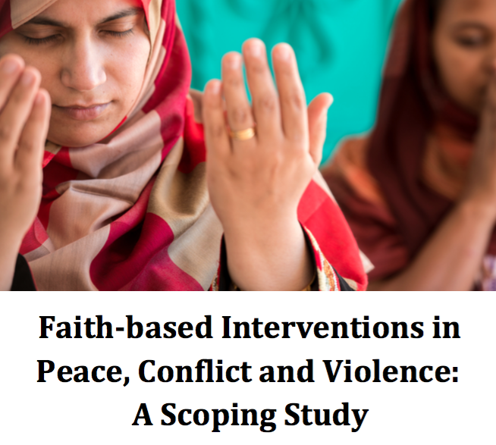
World Humanitarian Summit (WHS) Side Event
"One Humanity, Shared Responsibilities: Evidence for Religious Groups' Contributions to Humanitarian Response"
May 23, 2016
JLI, Soka Gakkai International, Asian Disaster Reduction and Response Network, Islamic Relief, Malteser International, Religions for Peace, World Evangelical Alliance, and World Vision coordinated the WHS Side Event "One Humanity, Shared Responsibilities: Evidence for Religious Groups' Contributions to Humanitarian Response". The event highlighted the evidence for the unique role and capabilities of local faith communities and religious actors in humanitarian response. The event featured a panel of local and national faith community leaders, as well as a panel on policymakers and high-level collaboration towards engagement of religious actors in humanitarian response. The Peace & Conflict LH Scoping Study “Faith-based Interventions in Peace, Conflict, and Violence” was also launched at the Side Event.
The event spotlighted five evidence briefs on religious actors in humanitarian response, produced by JLI, its members, and other partners worldwide. The briefs follow the five core commitments from the UN Secretary General’s report “One Humanity, Shared Responsibility.” Key messages and recommended actions provided evidence-based insight into LFCs and religious engagement in humanitarian response for the WHS and beyond.
Dissemination of proceedings and resources
JLI disseminated the evidence briefs and related WHS resources to 959 JLI members and interested parties with request to push through to their own networks.
Post Conference Resources and Media available online.

Moral Imperative Steering Committee and Evidence Working Group
From 2015-2016, JLI served on the Moral Imperative Initiative’s Steering Committee and has advised its strategic directions. Several JLI Board of Directors and Advisory Group members also serve on the Moral Imperative Steering Committee, including Azza Karam (UNFPA and JLI founding member), Ulrich Nitschke (GIZ), Adam Taylor (World Bank Group), Ruth Messinger (AWJS), and Caroline Lensing-Hebben (UNDP). The JLI’s coordinator, Jean Duff, co-moderated the Evidence Working Group (EWG), along with Dean Pallant of the Salvation Army. The EWG operated with the LH methodology, collaborating with 30 members to create a Guide to Evidence for Faith Groups. The EWG met monthly by teleconference and met in-person at the World Bank, hosted by the Global Delivery Initiative.
On September 23, 2016, JLI co-hosted Annual Review of Moral Imperative in NY
The work of the EWG culminated at this in-person meeting with the release of the guide for comments and summary of the collaboration. Next steps for the Moral Imperative will be forthcoming.
JLI organized two panels on Religion and Refugees (Religions for Peace Deputy General Secretary Kyoichi Sugino, Act Alliance, Christian Wolff, Catholic Relief Services Jennifer Poidatz) and on Faith engagement in Localization of Aid.

“What Works?: Evidence on the Role of Faith in Poverty Reduction” – Yale Conference
September 20-21, 2016
JLI cohosted the Evidence on the Role of Faith in Poverty Reduction Conference at Yale University partnering with International Care Ministries (ICM), Yale University and Innovations for Poverty Action (IPA). Conference speakers included Dean Karlan, Mark Brinkmoeller, Arnie Cole, David Sutherland, Julian Jamison, Mark Forshaw, Matthew Frost, Ulrich Nitschke, Bishop Efraim Tendero, Jean Duff, Sneha Stephen, Chris Udry, Dan Williams, Lincoln Lau, Adam Taylor, Bruce Wydick and Ed Stetzer. The conference included presentation of IPA’s analysis of a randomized clinical trial and examination of the impact of faith and poverty reduction. The conference had 78 attendees.

World Bank Civil Society Fall Meetings
October 6, 2016
JLI co-organized a panel on Religion and Sustainable Development:
Evidence for the capacities, activities and contributions of faith groups towards achieving the SDGS. The panel included:
- Pauline Muchina Director, Health Families, Healthy Planning, United Methodist Church,
- Erica Van Deren Program Management Officer- East West Africa, Middle East, Eastern Europe, World Vision
- Balkacem Nahi Regional Manager, Islamic Relief USA
- Martine Miller, Network of Religious and Traditional Peacemakers
The event had more than 50 attendees including World Bank employees and representatives from faith-based organizations.

Roundtable on the contribution of FBOs to the Sendai Framework
October 10, 2016
JLI partnered with Soka Gakkai International, the World Council of Churches, ADRRN and others to discuss Faith-Based Organization's contributions to the Sendai Framework and disaster relief reduction (DRR). The event convened 22 attendees with the presence of UNISDR, UNHCR, IFRC and ICRC. Roundtable participants highlighted the need to work closely with local faith communities to promote disaster risk reduction, particularly focusing on communities' networks to spread messages about disaster risk, building off research insights presented in the JLI's evidence briefs prepared for the World Humanitarian Summit. At the end of the roundtable, the SGI launched the "Restoring Our Humanity" exhibition in the atrium of the Ecumenical Centre.

International Partnership on Religion and Sustainable Development
JLI is honored to be admitted as one of the first partners of the International Partnership on Religion and Sustainable Development (PaRD). PaRD is a network on religion and development to enhance cooperation in achieving the 2030 Agenda together.

Communications Activities
Religion and Faith International Affairs Edition
The Review of Faith and International Affairs published a special series on Religion and Development edited by Jill Olivier. The collaboration received grant funding from JLI through DFID funding.

Articles include:
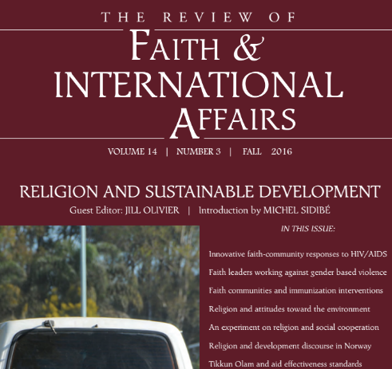
- Jean Duff co-authored with Mike Battcock, Azza Karam and Adam Taylor on high level partnership for faith and development
- Elisabet le Roux, Jill Olivier, Diana Arango & Veena O’Sullivan and others on gender and faith
- Jill Olivier on Interventions with Local Faith Communities on Immunization
- Alastair and Joey Ager on sustainable development and religion
- Azza Karam and Katherine Marshall on religion human rights and development
- John Blevins, Christoph Benn and Sandra Thurman on HIV-related Experiences

Global Delivery Initiative Case Studies
JLI with the Global Delivery Initiative at the World Bank initiated case studies on Episcopal Relief & Development, International Care Ministries and IMA World Health.

Newsletters
Mailchimp Campaign summary
- Quarter 1: 661 delivered, 36.9% opened*, 5.4% clicks
- Quarter 2: 686 delivered, 42.1% opened*, 4.8% clicks
- Quarter 3: 951 delivered, 53.6% opened*, 13.6% clicks
- Quarter 4: 934 delivered, 45.8% opened*, 8.6% clicks
- 1st New Website Resources Update Nov 8: 941 delivered, 38.1% opened, 10.1% clicks
- 2nd Web Resource Nov 17: 619 delivered(segmented to most active users), 46.3% opened, 13.1% clicks
- 3rd Web Resource Dec 21: 1,053 delivered, 30.1% opened, 4.6% clicks
*Includes electronically published URL clicks

WHS emails
- 1st: 34.8% opened, 9.5% clicks
- 2nd: 39.7% opened, 7.6% clicks
- 3rd: 39.4% opened, 4.4% clicks
- 4th: 39.9% opened, 8.4% clicks
- 5th: 36.8% opened, 7.0% clicks

Social Media Baseline Engagement

Follow us!

- Facebook: www.facebook.com/jliflc.connect (77 followers)
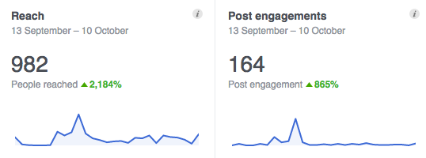

- Twitter: www.twitter.com/jliflc (155 followers)
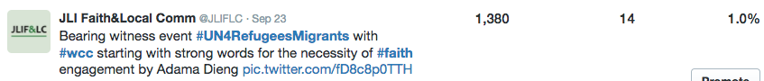
- YouTube (Past year: 3 videos from WHS and 135 views)
- LinkedIn (83 members in group)
- Instagram

The summary above gives a baseline for social media engagement. The number of connections per platform is as follows: Twitter (155 total, +102 more since 2015), Facebook (77 total, +36 since 2015), and Religion & Sustainable Development Group LinkedIn (83 total, +29 since 2015). This year, we created a YouTube channel for the WHS side event videos and established an Instagram account. Top posts are mainly event focused. The challenge is daily and weekly engagement. Also, building followers is slow. In the next year, we will be developing social media plans that will include LH engagement.

JLI Website
Since 2015, JLI continued website changes in order to increase website functionality and create a website useful for members and chairs of the LHs.
Changes include:
- LHs - Creating the Refugees and Forced Migration LH, Evidence Working Group LH and Guide.
- Member experience - Initiating registration process for new users to register to specific hubs and access our new membership directory. Members will be able to set up profiles to aid in facilitating greater engagement of hubs and membership.
- Resources - Updates the search and filter functionality to ensure ease of accessing specific resources for hubs and for areas of interest
- Organization pages – Profiles link to specific resources and members to help aid user navigation
- Calendar of events to complement news posts
- Reorganized JLI Leadership page
- Mobile friendly site

Our website will continue to allow members to contribute pasts, events and resources to encourage users to increase engagement. We are grateful for the continuing good work of our web designer, Ben Clowney at Hands-up.

JLI Website Analytics Report
The figure below shows all time page views since the website launched in 2014. Since October 2015, total unique users 16,289 used the site. Since 2015, website page views increased more than 22%, number of users and sessions increased 39%.

JLI Page views (All time)

In August 2014, we started the new JLI website. The most active usage of the site generally occurs around JLI hosted events. In these cases, JLI provided online information platforms, such as the Religion & Sustainable Development Conference in July 2015 and the World Humanitarian Summit Side Event in May 2016.

Annex I: LH Updates
Hub Name: Gender-based Violence | Hub Co-Chairs: Veena O’Sullivan (Tearfund), Elizabeth Dartnall (SVRI), Diana Arango (World and Shereen El Feki
Hub status: Active | Number of Members: 98
Hub accomplishments:
- Face to face meeting at WHS and WHS brief
- Recruited new Co-Chair: Shereen El Feki, Promundo and Munk School of Global Affairs, University of Toronto though reorganizing for
- JLI Board Presentation and RFIA article
Challenges:
- We have been proactive in accessing funding for specific pieces of work and therefore a face to face meeting of members has not yet happened.
- Need to expand membership and organise greater involvement along preferred themes, which would lead to sub Hubs and engage in greater joint working.
Recommendations regarding this Hub going forward:
- Invest in facilitating thematic sub Hub's with a lead facilitating the work going forward.
- Expand membership to actively include other faiths (it is currently dominated by the Christian faith)
- Expand the ‘active’ Hub membership with a focus on different faiths and communities
- Strengthen the core secretariat and leadership of co-chairs
- Develop priority research questions/themes
- Development of tools and partnership frameworks
- Funding access

Hub Name: Mobilisation of Local Faith Communities (formerly Capacity Building) | Hub Co-Chairs:  Christo Greyling (World Vision), Catriona Dejean (Tearfund),  Academic chair TBD
Hub status: Restarted Dec 2016
Hub accomplishments:
- Met in Dublin in Dec 2016 to relaunch hub
- Started gathering LFC case studies for discussion and discussion of member webinars
Recommendations regarding this Hub going forward:
- Expand the ‘active’ Hub membership with a focus on different faiths and communities
- Strengthen the core co-chairs
- Develop priority research questions/themes
- Work towards presentation at Oct 2017 localisation of humanitarian aid forum

Hub Name: Peace & Conflict | Hub Co-Chairs: Sarah Pickwick (World Vision UK), Lucy Moore (Islamic Relief UK), Alpaslan Ozerdem (Coventry University)
Hub status: Active | Number of Members: 130
Hub accomplishments:
- 60-page detailed Scoping Paper “Faith-based Interventions in Peace, Conflict and Violence”, produced collaboratively by Coventry University and the JLI Hub members
- Launch of the Scoping Paper at the World Humanitarian Summit
- Produced Evidence Brief on Peace, Conflict, and Humanitarian Response as part of five WHS Evidence Briefs
Recommendations regarding this Hub going forward:
- Invest in facilitating thematic potential sub-groups on response of FBOs and prevention of conflict with a lead facilitating the work going forward.
- Expand the ‘active’ Hub membership with a focus on different faiths and communities
- Strengthen the core co-chairs
- Develop priority research questions/themes
- Development of tools and partnership frameworks and funding access

Hub Name: Refugees and Forced Migration | Hub Co-Chairs:  Elena Fiddian-Qasmiyeh (UCL)  Sadia Kidwai (Islamic Relief UK)
Hub status: Launched Sept 2016
Hub accomplishments:
- Hub TOR and in-person meeting in NY in conjunction with the start of UNGA
- Hub scoping study proposal and timeline completed
- RFM Twitter account launched
Recommendations regarding this Hub going forward:
- Expand the ‘active’ Hub membership with a focus on different faiths and communities
- Finish scoping paper by summer 2017
- Work towards key events in 2017 to present findings of scoping study

Hub Name: Resilience in Humanitarian and Disaster Situations | Hub Co-Chairs: Alastair Ager & Helen Stawski
Hub status: Cycle Completed Summer 2016 (after four years) | Number of members: 26
Hub accomplishments:
- Hub leadership actively shaped religious engagement at the World Humanitarian Summit (May 2016) and, together with co-hosts Soka Gakkai International
- Led the WHS Side Event focusing on evidence for religious actors contributions to humanitarian assistance
- Disseminated WHS Evidence Briefs
- Scoping report 2012
- UNHCR High Commissioner’s Dialogue on Faith and Protection (JLI members shaped the agenda and leading break out discussions)
- Luce Foundation funded research programme into the role of LFCS in assisting Syrian Refugees in Jordan

Conclusions:
After four years of operation, the Resilience Hub concluded its activities following the World Humanitarian Summit. We are grateful for the excellent leadership of Alastair Ager and Helen Stawski to the Hub! Many members are transitioning to the Peace & Conflict Hub or the Refugees and Forced Migration LH.

Hub Name: Evidence Working Group | Co-Moderators:  Jean Duff, JLI  Dean Pallant, Salvation Army
Hub status: Active | Number of Members: 30
Hub accomplishments:
- Monthly teleconference collaboration and full-day, in-person meeting at the World Bank with group members to produce the Guide to Excellence in Evidence
- First draft of the Guide to Excellence in Evidence launched at the 2nd meeting of the Moral Imperative in New York City
- Draft online and available for comment at http://guide.jliflc.com/resources/
Challenges:
- Aligning Guide with overarching goals of the Moral Imperative and other working groups
Recommendations regarding this Hub going forward:
- Receive feedback from the potential users of the Guide, particularly local and national faith communities
- Revise based on feedback and continue to build the Guide’s library of examples

Inactive Hubs: HIV and Maternal Health, Immunization

Annex II: Detailed Web Analytics Report

Summary
The JLI website continues to be a knowledge conveyer for LHs and event resources. The website traffic has increased more than 20% since 2015 and resource downloads totaled 286. The page views for all time is shown below.

Total Page views between Oct 2015 – Sep 2016 = 41,717
Unique Page views: 30,827

The table below compares quarterly website analytics since the last annual report in October 2015. Since October 2015, total unique users 16,289 used the site. Since 2015, website page views increased more than 22%, number of users and sessions increased 39%.

Indicators | All time | Avg Quarter 2015 | Avg Quarter 2016 | Oct 15 – Dec 15 | Jan 16 – Mar 16 | Apr 16 – Jun 16 | Jul 16 – Sep 16 | 2015-2016 Total | % increase from 2015
Users | 21,746 | 2,014 | 3,184 | 2,548 | 2,548 | 4,157 | 3,482 | 12,735 | 39
Sessions | 31,077 | 2,877 | 4,331 | 3,300 | 3,374 | 5,714 | 4,937 | 17,325 | 39
Page Views | 80,235 | 8,077 | 10,429 | 7,883 | 8,387 | 14,150 | 11,297 | 41,717 | 22

WHS Traffic
On May 2016, JLI hosted the WHS side event with many other partners. Resources from the summit are posted on JLI’s website.
WHS Special Session/ pages | Total Page Views | Unique Page Views
Home Page | 770 | 503
Outcomes & Next Steps | 429 | 303
WHS Evidence Brief 1 | 207 | 171
WHS Evidence Brief 2 | 115 | 84
WHS Evidence Brief 3 | 187 | 153
WHS Evidence Brief 4 | 127 | 102
WHS Evidence Brief 5 | 77 | 61
Key Messages of WHS Evidence Briefs | 185 | 133
Total | 2,097 | 1,510

Top 5 pages on JLI website (Oct 2015- Oct 2016)
Conference attendees and organization pages were in the top page views, which supports the web change plan to include formal membership including organization profiles and individual profiles.
 | Page Views | Unique Page Views | % Change from last year
JLI Home Page | 12,706 | 7,995 | +3%
JLI Resources Pages | 9,017 | 7.359 | +28%
JLI News | 2,398 | 1,774 | -
R&SD Conference Home Page | 941 | 596 | -
WHS Side Event Home Page | 770 | 503 | -

Top 10 JLI Resources (Oct 2015- Oct 2016)
Of the top 10 resources, six of the 10 are shorter resources (about 10 pages or less).
 | Page Views (previous year) | Unique Page Views (previous year)
WHS Evidence Briefs | 713 | 571
Faith-based Measurement and Metrics Resources | 356 | 256
Peace & Conflict Scoping Study | 232 | 202
WHS Key Messages | 185 | 133
Gender Based Violence Scoping Study | 160 | 126
R&SD Key Findings | 157 | 133
Moral Imperative Framework | 155 | 137
JLI Theory of Change | 155 (262) | 132 (220)
Building Effective Partnerships Report | 130 (250) | 109 (208)
GBV and Faith Policy Brief | 107 | 86

Referrals
 | Sessions | % Change from last year | New Users | % Change from last year
Organic search* | 6,894 | 80% | 4,781 | +111%
Referrals | 5246 | 13% | 4,030 | +18%
Direct | 4321 | 14% | 3,014 | +.5%
Social Media | 803 | 149% | 429 | +117%
*A user coming from an organic search is from any search engine, referrals are from another website with a link to JLIFLC.com, direct referrals are users with a website link directly to a webpage on JLI’s site and social media referral is from any of our social media platforms (mainly Twitter and Facebook)

Annex III: Timeline
FOR SIGNAL JLI EVENTS AND MILESTONES

2011
April 7 | Preliminary TOR for Joint Learning Initiative for the role of Local Faith Communities (LFCs) in tackling poverty

2012
January | 12 Founding Steering Committee members
 | Jean Duff signs on as part-time Coordinator and begins work
 | Seed funding from a variety of partner organisations including: CAFOD, Christian Aid, The MacLellan Foundation, Tearfund, World Vision, Samaritan’s Purse and UNFPA
 | Tearfund provides organizational umbrella for JLI project
 | Preliminary website set up
HIV and Maternal Health (MH) | Learning Hub (LH) Launched and Azza Karam UNFPA and Sally Smith UNAIDS Co-Chairs (27 members)  Ann Smith and Jo Kaybryn engaged to support the Scoping Paper preparation process
Resilience in Humanitarian Situations | LH Launched and Rachel Carnegie and Helen Stawski International Development staff, Archbishop of Canterbury Co-Chairs (26 members)
Immunization | LH concept developed Jill Olivier University of Capetown and J Duff convening Co-Chairs
Working Group on Evidence | For LFCs Activity and Impact within INGOs- Catriona Rust, Tearfund and J Duff Co-Chairs (15 members)
 | Web based Information Utility and Learning Exchange Platform on Faith and Local Communities proposed

2013
February | JLI Briefing on Evidence for DFID policy makers.
 | J Duff and Matthew Frost brief UN Interagency Task Force on Religion and Development: “Evidence of faith-based contributions towards development”
 | Survey of Steering Committee members and LH members on JLI progress and opportunities completed with support from McKinsey & Co
Several hubs participated in the UN staff college training in Rome
New LH on Child Survival and Maternal Health proposed
NGO Briefings on Evidence for Faith Groups’ activity and contributions hosted by CAFOD in London and by World Vision in DC

Capacity Building | LH Joint paper in development  Astrid Foxen Tearfund and J Duff Co-Chairs (20 members)
Gender-Based Violence (GBV) | LH TOR completed in December
HIV and MH | LH report completed CAFOD PP deck for presentation of HIV and MH Hub Scoping Report completed. Presentation to Catholic Health Association of Nigeria. Georgia Burford
Immunization | LH Initial Brief completed
Refugees | FMO Resource Summary on Religion and Humanitarianism
Resilience | LH Scoping Study and Policy Brief Completed  Presentation to UNHCR Dialogue on Faith and Disaster Response; provided input on faith role to World Disasters Report research questions framed; research proposals developed
Working Group on Evidence for LFCs | Becomes the Capacity Building LH

2014
Steering Committee expands to 18 members. SC clarifies that JLI is a knowledge management platform and not a research platform.
JLI funders: | CAFOD, Christian Aid, the MacLellan Foundation, McKinsey & Company, Samaritan’s Purse, Tearfund, UNFPA UNICEF and World Vision International
HIV and MH | LH Co-Chairs: Azza Karam, Christo Greyling World Vision and Julie Clague, Glasgow University. Completes its work, report disseminated
GBV  April | LH Launched  Co-Chairs: Veena O’Sullivan Tearfund and Lizle Loots SVRI
June  December | In person meeting at Ending Sexual Violence in Conflict Summit  Research grant application about role of LFCS in response to GBV in DRC.  Stellenbosh applied on behalf of the JLI GBV Hub.
Resilience | LH now co-chaired by Helen Stawksi now at Islamic Relief and Alastair Ager Columbia University, continues to engage with UNHCR to shape the Dialogue on Faith and Disaster Response.  Luce Foundation funds study of role of LFCs in building resilience among Syrian Refugees; Alastair Ager Columbia, University and Elena Fiddian-Qasmiyeh Oxford Center for Refugee Studies
Capacity Building for LFCs | Met for two days to discuss theory of change and measurement and metrics; Joint paper on Theory of Change for Capacity Building for LFCs produced with facilitation from Cathy James
Immunization | LH Scoping Review and annotated bibliography completed by Jill Olivier.  Presentation to GAVI Board Chair, Advocacy staff team and others
 | JLI active in meetings with the Lancet editorial team to shape a Lancet Series on Faith-based Health Care Delivery and draws experts from JLI network into writing teams for key articles
 | To communicate evidence from JLI LHs, we developed a concept for conference on “Drivers for Effective Engagement and Partnership between Faith and Development entities”

2015
GBV | LH engages with UK Foreign office (DFID) in raising awareness of faith contribution to SGBV. Interfaith meeting. London.  LH Scoping Paper
Peace and Conflict | LH launched, Sarah Pickwick, World Vision, Lucy Salek, Islamic Relief, and Alp Ozerdem Coventry University Co-Chairs
Resilience  May | LH and Azza Karam supported faith and humanitarian response meeting in Netherlands
McKinsey & Co | Report commissioned by JLI  “Building More Effective Partnerships between Public Sector and Faith Groups” based on 40 interviews with senior development professionals; McKinsey provided pro-bono assistance to designing the conference, with the Report as key input
July | “Religion and Sustainable Development (R&SD): Building Partnerships to End Extreme Poverty” conference co-hosted and funded by JLI World Bank, USAID, GIZ, GHR Foundation, World Vision, CRS, AJWS, IMA World Health, Islamic Relief USA, CMMB, Tearfund and McKinsey & Co.  JLI LH Co-Chairs led the development of conference thematic sessions to present evidence.  Dedicated Online information platform supports 43 brief evidence-focused presentations; 140 participants including over 40 from global south.  German Government announces intention to establish bilateral coordinating mechanism for religion and development (PaRD)
 | Lancet Series on Faith-based Health Care Delivery launched at R&SD conference
 | Drawing on conference recommendations, JLI SC explores future directions leading to development of new three year operating plan
 | JLI participates with UN Interagency Taskforce on Religion and Development in “DUF process” exploring cross sector collaboration and preparing for faith response to launch of SDGS
September | JLI co-leads with UN IATF, World Bank, WCC Act Alliance and others the development of the Faith-based Action Framework on achieving the SDGs, presented at the UNGA prior to the launch of the SDGs
Evidence Working Group (EWG) | Co-Chairs J Duff and Dean Pallant of Salvation Army, one of three working groups established. EWG explores possible activities and decides to collaboratively develop a “Guide to Excellence in Evidence for Local Faith Communities”
October | Steering Committee meets in person in London; votes to continue JLI for another 3-year phase, with focus on: more effective communication with policymakers, strengthened governance, expand Board leadership, create Advisory Group, increase financial resources; transition inactive LH to thematic areas on the website  J Duff elected to Steering Committee of Moral Imperative, representing the EWG and JLI
December 2015 | Detailed planning for “Evidence Summit” Conference Development in partnership with World Bank, for July 2015 delivery. JLI Learning Hub Chairs actively shaping conference sessions, and J Duff raising $225,000 and managing the staging of the event in partnership with the World Bank
* 2012- 2015 JLI annual budget averages £72,000 per year (without the RSD conference)

2016
 | JLI participates in launch of the German government’s Partnership for Faith & Development (PaRD) and becomes one of the first partners
May | Under direction of Alastair Ager, Queen Margaret University, 3 LHs (Resilience, Peace and Conflict, GBV) with 22 experts collaborate to develop 5 Evidence Briefs for presentation at the World Humanitarian Summit (WHS)
EWG | Transitioned to JLI LH (25 members)
Peace and Conflict | LH Scoping paper launched at the WHS
 | JLI presents side event on Activity and Contributions of Faith Groups to Humanitarian Response at WHS
Resilience | LH after 4 year cycle completes its work
 | GHR approves 3 year grant to JLI towards general operating expenses
July  Refugees and Forced Migration (RFM) | LH Launched  Co-Chairs: Elena Fiddian-Qasmiyeh, University College London and Sadia Kidwai, Islamic Relief
 | New 32 member JLI Board meets for the first time by phone
 | Executive Committee of the JLI Board meets for the first time
 | JI Advisory group constituted with 11 members
September | JLI Knowledge Manager hired—first JLI FT employee
Sept 19  RFM | LH Policy Note  Meeting in-person  Applications for research funding submitted  JLI RFM partners for 4 year AHRC-ESRC research project on Local Community Experiences of Displacement from Syria: Views from Lebanon, Jordan and Turkey (PI Elena Fiddian-Qasmiyeh, Co-investigators: Alastair Ager, Anna Rowlands and Lyndsey Stonebridge).
 | JLI signs on as co-host for October 2017 International Forum: Localizing Response to humanitarian need: the Role of Religious and FBOs
 | Organizational auspices of JLI project under review; Options for US based tax exempt platform for JLI under development
Sept 20-21 | JLI co-hosts conference on “Evidence for Faith Impact on Poverty” at Yale, with International Care Ministries and Dean Karlan; expert session on spiritual metrics. Many JLI members present.
Sept 22 | JLI co-hosts Annual Review of Moral Imperative (MI) and organizes 2 panels for that meeting on Religion and Refugees and on Faith engagement in Localization of Aid
EWG | Draft on-line Guide presented at MI annual meeting
 | Special issue on Religion and Development published in the Review on Faith and International Affairs; Guest editor Jill Olivier, with funding provided by JLI, from a DFID grant; several articles building on presentations at July 2015 RSD conference
October 10 | JLI co-hosts with World Bank session at World Bank Annual meetings, on Evidence for Faith Groups Contributions to Ending Extreme Poverty
 | JLI cohosts with Soka Gakkai International, World Council of Churches and ADRRN- Faith-Based Organization's contributions to the Sendai Framework and disaster relief reduction
JLI Website revamped
JLI RFM Twitter account launched: @JLI_Refugee_Hub
Oct 25 | JLI in-person Board meeting considers options for increasing effectiveness of communications to development and humanitarian decision makers re more fully engaging faith networks.  McKinsey and Co provide valuable pro-bono support
December 2016 Mobilisation of Local Faith Communities (formerly Capacity Building) | LH meeting at Trinity College Dublin, Ireland

JLI staff
Jean Duff has served as part-time Coordinator since 2012. Through her NGO, Partnership for Faith & Development (PFD), she has provided hosting and support services including freelance and consulting personnel, event management, fundraising support, hosting JLI Knowledge Manager, as well as legal and accounting support. Helena Manguerra, project Coordinator at PFD, provided superb part time support to JLI from February 2015- August 2016. Stacy Nam began work as full time Knowledge Manager September 1, 2016. JLI is well supported by Hands Up web services, and by a variety of freelancers, and student interns.

Annex IV: Financial Report
Unaudited financial report for January –December 2016

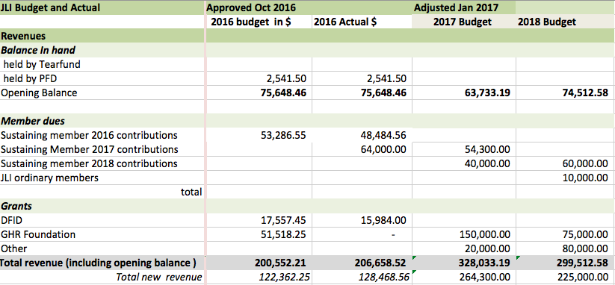
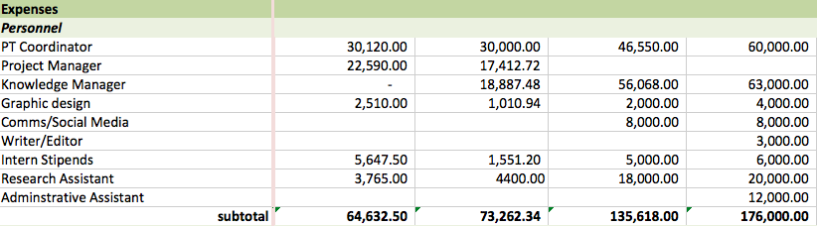
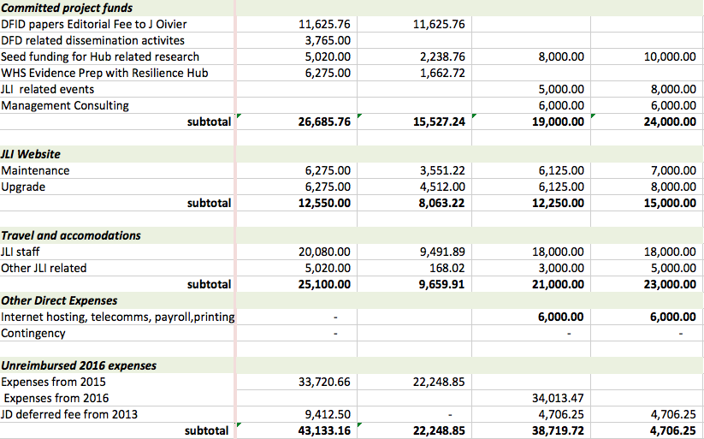
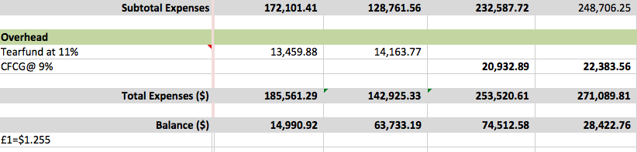

See Annex: Detailed Analytics Report) Sessions refers to a group of interactions that take place in a website. A session can contain multiple page views. A single user can open multiple sessions per day. A session ends after 30 minutes of inactivity with the site, or at midnight.

