UNAIDS Community Mobilization Division Update for Faith-Based Organizations responding to HIV
This is a 2016 autumn update on some of the engagement by faith-based organizations on HIV this year; many events are under the auspices of the PEPFAR/UNAIDS FBO Initiative. It gives you a summary of global activities that took place this spring and summer. Please do forward this update to your colleagues and other interested friends. Anyone wishing to be included in the mailing list, or wanting to include an item for circulation should send an e-mail to Sally Smith smiths@unaids.org with a copy to Julienne Munyaneza jmunyaneza@gmail.com
Do follow us on social media: Twitter: @SallyLynnSmith and Facebook: civil society dialogue space
The activities started in the spring with two consultations on Early Diagnosis and Treatment for Children and Adolescents Living with HIV: Strengthening engagement of Faith-based organizations. In April and again in May, Caritas Internationalis brought together global partners in two consultations to discuss the role of faith-based organizations and the private sector in closing the global HIV testing and treatment gap for children living with HIV and develop an action plan for future work. The meetings, held in Vatican City were co-organized with UNAIDS, the United States President’s Emergency Plan for AIDS Relief (PEPFAR) and the Vatican’s Bambino Gesù paediatric hospital. See links for the stories, and report. His Holiness Pope Francis sent a special message to the meeting.

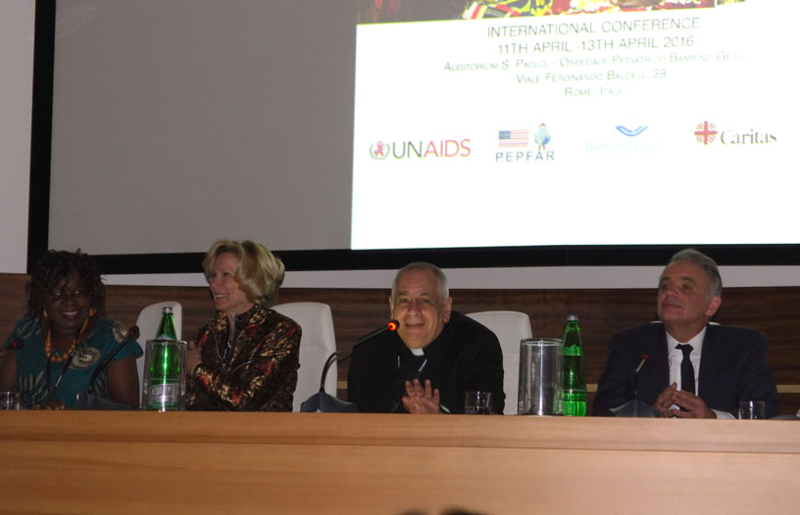

Photo UNAIDS
Panelists at the Vatican meeting

This year has been an important policy setting year for the AIDS response.
A new Political Declaration on AIDS was agreed by the UN General Assembly in June. Faith Related Events leading to the UN General Assembly included:
A video message released by Justin Welby the Archbishop of Canterbury on May 18th, entitled “Archbishop urges ‘great further step’ to end AIDS by 2030,” with the aim to help mobilize critical resources to communities most at need of HIV services. In his address, the Archbishop recognized the great progress already made since the beginning of the epidemic, but pointed out that some communities were being left behind. Here is the video
June 7, an Interfaith Service (IS) was held as a side event to the HLM in New York. The service was a time to pray for a strong political declaration on HIV and AIDS and to strengthen the engagement of faith communities in the comprehensive response to HIV. The service resulted in A Call to Action to reduce stigma and discrimination; increase access to HIV services; defend human rights; and ensure testing and treatment for all, including children.
For more on the advocacy of different faith communities in the lead up to the HLM please see the link, and watch the video message from WCC general secretary Olav Fykse Tveit.

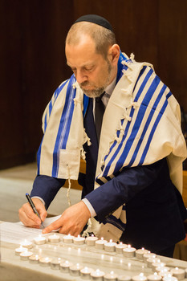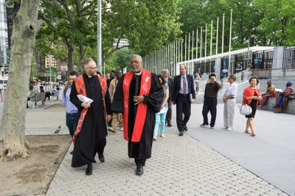
A Rabbi at the IS, June 7 Religious Leaders walking from the UN to the Church Center for the IS Photos WCC
July 18-22: 21st International AIDS Conference, Durban, South Africa
For many years now, Faith based organizations have held an Interfaith pre-conference to share lessons learned from faith engagement in the HIV response take a stand on the leading issues of the Conference. The Interfaith pre-conference is convened by the World Council of Churches Ecumenical Advocacy Alliance (WCC-EAA). In Durban, more than 250 people participated in FBO pre-conference sessions in advance of the 21st International AIDS Conference. A joint plenary with Catholic pre-conference participants discussed the centrality of faith-based organizations and communities to the super Fast-Track response for children, building on the consultations in Rome.

In the main International AIDS conference agenda a bridging session addressed “The challenges of faith responses to the AIDS epidemic.” The session reported on work done to respond to two of the papers in a special edition of the Lancet on Faith and health care in 2015: one on data and one on controversies. It was noted that faith community responses do not always match international strategy and that faith is only one of many factors contributing to issues such as child marriage, female genital mutilation, violence against women, the provision of sexual and reproductive health services and stigma related to HIV.

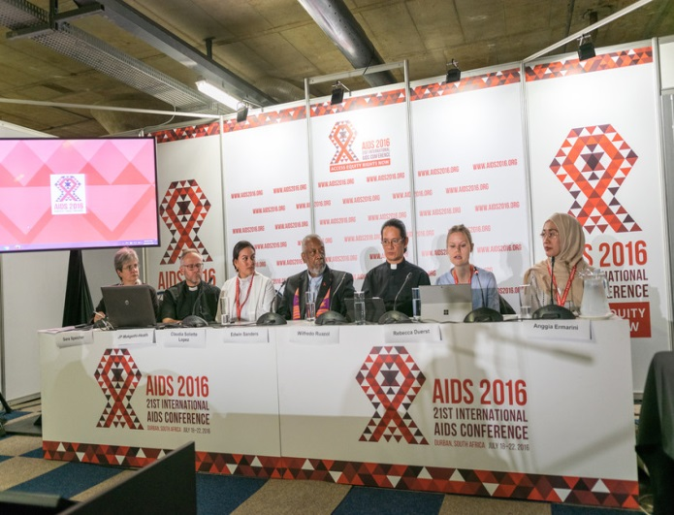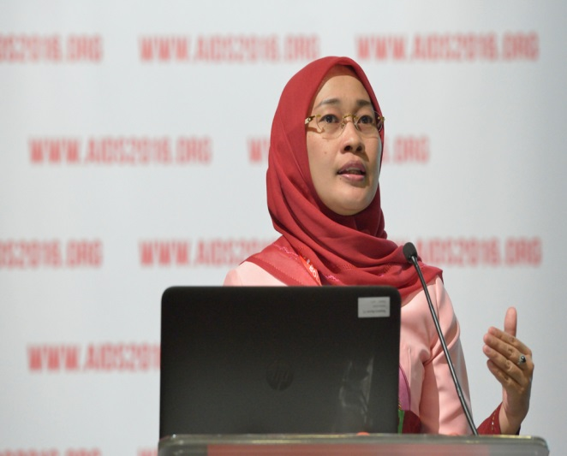

Panelists at the 21st Interfaith Preconference in Durban A participant from Indonesia
Photos WCC

September 20: Interfaith Prayer Breakfast (IPB), New York City: “From Commitment to Action”

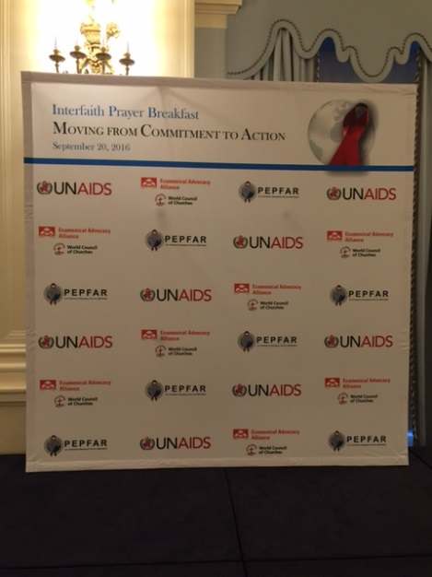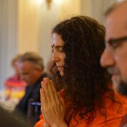
Photos Black AIDS Institute
On the side-lines to the opening of the UN General Assembly the WCC-EAA in collaboration with UNAIDS, PEPFAR and the UN Interagency Task Force on Religion and Development organized a successful interfaith prayer breakfast (IPB) that offered faith leaders opportunities to strengthen relationships and forge new partnerships that would enable them to accelerate the global response to HIV. Rev. Phumzile Mabizela, Executive Director of INERELA+ did a wonderful job as moderator. Over 100 faith leaders from diverse religious traditions attended the IPB and agreed to support a coordinated faith-based effort – turning the Political Declaration into action.
Dr Luiz Loures, UNAIDS Deputy Director for Programmes who leads UNAIDS’ efforts in leveraging critical support to countries to end AIDS by 2030, emphasized how engaging the faith community is paramount to achieving the UNAIDS Fast-Track Targets and the Sustainable Development Goal target of ending the AIDS epidemic by 2030.
At the IPB, the call to action issued in June was reiterated with strong follow-up recommendations and commitments to action over the next five years to ensure a Fast-Track faith-based response to end the AIDS epidemic by 2030.
Symposium on Keeping the Faith in Development: Gender, Religions & Health”
Following the breakfast, a lunch-time technical session highlighted recent publications in the area of faith, HIV, human rights, sexual and reproductive health. Participants from the breakfast meeting took part in the symposium co-organized by the Secretary General’s Interagency Task Force on Faith and Development (IATF) and a range of partners. It created, and offered space, to explore some of the difficult conversations faith communities encounter when seeking to address and resolve sexual and reproductive health challenges. A wide range of panelists (see photo below) offered diverse but constructive views, which was followed by lively discussion.
During the symposium, resources published earlier this year: by the World Council of Churches (WCC), entitled Dignity, Freedom and Grace and a joint UNFPA-NORAD report Religion, Women’s Health and Rights: Points of Contention, Paths of Opportunities were made available to participants.
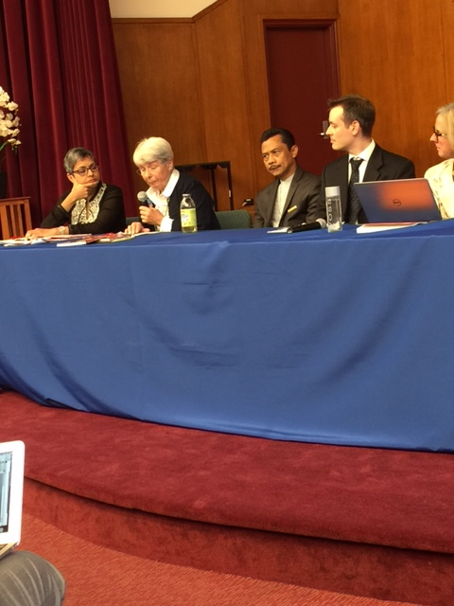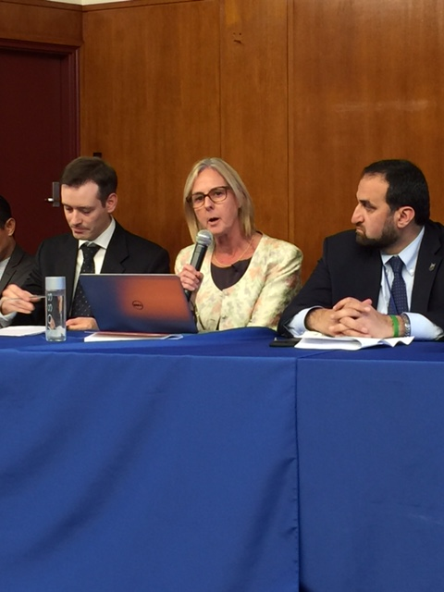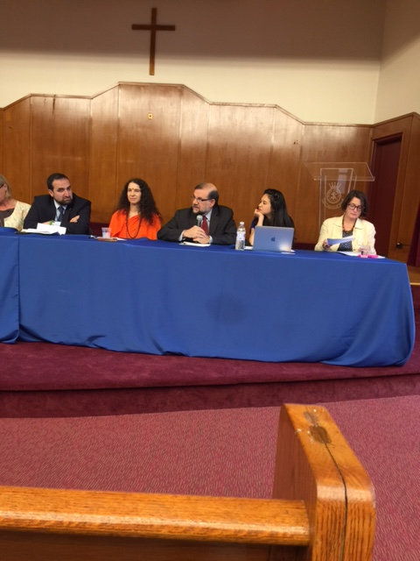

Photos WCC

So what’s next?
- Two country consultations in Kenya and Zambia to explore collaboration between national responses to HIV in partnership with faith partners and the PEPFAR/UNAIDS FBO Initiative. From 10-14 October, a National HIV Interfaith Consultation will be held in Nairobi, Kenya, under the auspices of the NACC, WCC-EHAIA, PEPFAR & UNAIDS
- From 18-21 October, a similar National Interfaith HIV Consultation will be held in Lusaka, Zambia under the auspices of NACC, WCC-EHAIA, PEPFAR & UNAIDS
- Catholic HIV/AIDS Network (CHAN) Meeting, Geneva, 10-11 October 2016; contact: Stefano Nobile: snobile@caritas-internationalis.com.
- The Abuja conference- and first annual meeting of the Partnership for Religion and Development (PaRD) October 17-20.
- The UN System Staff College (UNSSC) is holding a Strategic Learning Exchange on Engaging Faith Organizations and Communities for Sustainable Development in Bonn, Germany, 15-17 November, 2016. Deadline of registration is November 8, 2016. For questions, please email sustainable-development@unssc.org.
- World AIDS Day: http://www.unaids.org/en/resources/campaigns/WAD2016
- UNAIDS PCB 6-8 December 2016. You may be interested to read more about the thematic session on the role of communities in ending AIDS by 2030 from the previous meeting.

HIV Useful links and Resources
UNAIDS Documents:
- Invest in Advocacy: Community Participation in accountability is Key to Ending the AIDS Epidemic
- Stronger Together: From Health and Community Systems to Systems for Health

New WCC webpages & Publications on HIV:
- "Getting Involved" on the leadership commitments to HIV, including the WCC Central Committee Pastoral Letter
- "What we do" on the clergy testing campaign worldwide and WCC theme for World AIDS Day – 1 December 2016
- Passion and Compassion: The Ecumenical Journey with HIV by Manoj Kurian
- WCC-EAA: Faith-based groups bring hope for a fast-track HIV response

Julienne Munyaneza
UNAIDS-PEPFAR FBO Initiative Consultant
(jmunyaneza@gmail.com)

