PARTNER SPOTLIGHT: Doing More with Less in Uganda
Four hours east of Kampala, in a small hospital in Mbale, Uganda, children and parents from across Africa gather to seek treatment for Spina Bifida, brain tumors, and other life-threatening neurological conditions at the first pediatric neurosurgical teaching hospital in Sub- Saharan Africa. One of these diseases, Hydrocephalus or “water on the brain,” occurs when the protective fluid that normally circulates around the brain fails to drain into the body, causing the fluid to build up in the head. In infants, whose skulls have not yet hardened, this build-up causes the head to swell and can cause severe developmental disabilities or death.
Hydrocephalus occurs worldwide, but in a country like the U.S. it is diagnosed quickly, treated effectively and poses fewer long-term risks. In the developing world, diagnosis is slower and good treatment is rarely available to the poor, allowing time for pressure in the skull to damage a child’s mental development. There is only one neurosurgeon for every 10 million people in Uganda, compared to one for every 90 thousand people in the U.S. Traditional treatment of hydrocephalus— insertion of shunts—is also prohibitively expensive and requires sustained medical monitoring beyond the reach of most children in the developing world.
In the early 2000s, Dr. Benjamin Warf, an American pediatric neurosurgeon, pioneered an alternative, low cost treatment at CURE Children’s Hospital of Uganda (CURE Uganda). Outcomes are just as safe and effective as shunts but require far less medical infrastructure and post-surgical maintenance. Dr. Warf’s procedure is so significant that in 2012 he was awarded a “Genius Grant” by the MacArthur Foundation. Dr. Warf trained two Ugandan doctors, Dr. John Mugamba and Dr. Peter Ssenyonga, to carry on in his footsteps. Today CURE Uganda performs more hydrocephalus surgeries than any other facility in the world and trains doctors from all over the globe, including the U.S., in the technique.
Since 2001, USAID/ASHA has provided more than $1 million to CURE Uganda, supporting the construction of a new outpatient ward and the procurement of a CT scanner, among other items. USAID/ASHA’s most recent grant, which ended in 2013, enabled CURE Uganda to construct new operating rooms that increased capacity by 20 percent. That’s roughly 250 more life-saving surgeries annually; 250 more children who will travel to remote Mbale, Uganda, and receive the most innovative, effective treatment at a globally renowned hospital; and 250 more children with better opportunities in life.
Drs. John Mugamba and Kachinga Sichizya meet with the mother of one of CURE Uganda’s patients.
Bryce Alan Flurie/ CURE

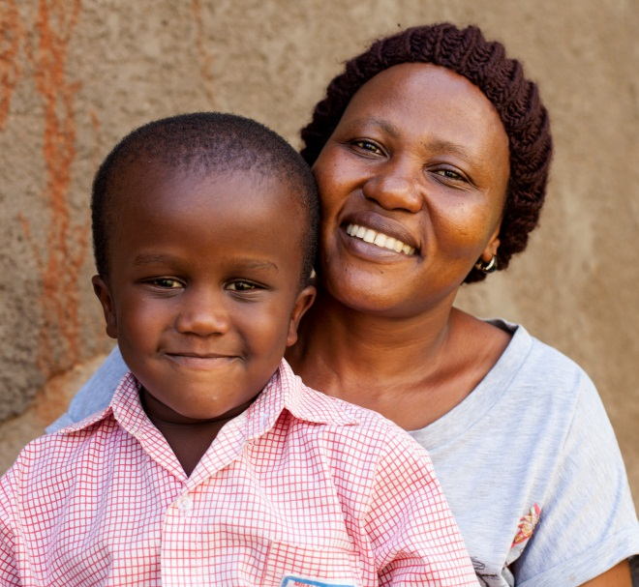
Jessie and his mother Rita – a CURE Uganda success story.
Bryce Alan Flurie/ CURE

