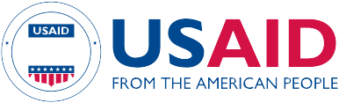
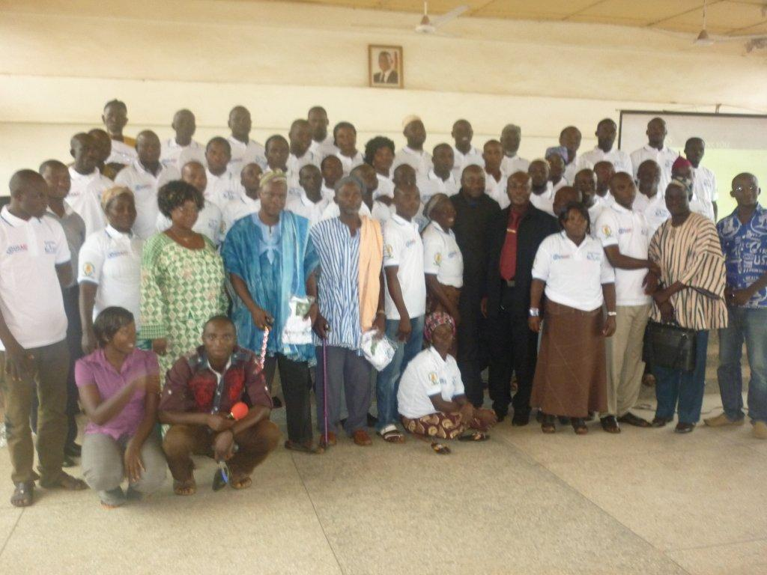

Key Findings:
Partnership based on mutual trust and consultation leads to positive gains in project implementation

Capacity building programs targeting the needs and gaps within the GHS system was very helpful in the results achieved

Active engagement of partners in the design and implementation of interventions is necessary for project success and lasting results.

Innovation in Partnerships for enhanced maternal and newborn care services in a rural setting: the case of USAID funded project in rural Ghana
Increasingly, health ministries in many developing countries have recognized the need to engage diverse actors (the Government, the private sector/NGOs and the target communities) to increase the provision, coverage, quality and utilization of health services. Though the success of this normally depends on factors such as resources, expertise and infrastructure, what is critical is how innovative the engagement process has being between and within these actors. Therefore, with limited resources, expertise and infrastructure, projects often halt prematurely or in most cases fail to achieve their goals and objectives. This brief provides an overview of how an innovative partnership arrangement among the Catholic Relief Services, the Ghana Health Services and communities in the implementation of a child survival project dubbed Encouraging Positive Practices for improving Child Survival (EPPICS) has helped improve maternal and newborn health indicators in the East Mamprusi District of Ghana.
The EPPICS project is funded by the U.S. Agency for International Development through the Child Survival and Health Grants Program.

Background
Partnership between the health services, the NGOs and participants communities in implementing successful maternal and child health interventions requires an understanding of the roles and responsibilities of each actor and what motivates and inspires their contributions. Collaboration among diverse actors often results in challenges and in some cases a total failure, however this brief argues that within the framework of transparency, mutual trust and support, distribution of roles as well as innovative resource pooling, resounding success is achievable.
PROGRAM LEARNING BRIEF
Such was a framework on which the EPPICS Project was designed. With a goal of reducing maternal and newborn deaths in the East Mamprusi District, EPPICS combines both facility and community-based approach to reach its 51,000 target beneficiaries (27,000 women of reproductive age and 24,000 children under five). Through three strategic actors: CRS and GHS and USD coupled with seven different community-based agents (Traditional Birth Attendants, Positive Deviant Mothers, Healthy Mothers and Newborn Care Committees, Community Health Volunteers, Zonal Coordinators, Community Emergency Transport Committees and Council of Champions), the project implements maternal and child health care in 11 health facilities and 240 communities with a total population of more than 120,000 inhabitant.

Project Design

The EPPICS project was designed with two main components: facility-based (involving 11 health facilities) and community-based (consisting of 240 communities) components and has three technical intervention areas with varied levels of efforts namely: Maternal and Newborn care (60%), Nutrition (30%) and Malaria in Pregnancy (10%). For EPPICS to achieve its goal of reducing maternal and infant deaths, three key strategies are being deployed: Community engagement through mobilization and sensitization, Empowering the health staff and the community-based agents through capacity building, Monitoring and facilitative supervision and the use of data in decision making process. To be able to roll out these key strategies successfully, partnerships and assignment of roles and responsibilities was key. The various tasks were distributed as presented in Table 1 across the key actors.

Table 1 Partnership framework
Catholic Relief Services | Grant management and administration, capacity building, monitoring supervision and learning: Facilitated the organization of Emergency Obstetric Care training, Essential Newborn Care, Essential Nutrition Action for health staff and construction of tippy taps to promote hand hygiene and clean deliveries, and Lactation management and other project strategies including Construction of community giant scoreboard and its management at the community level as well as facilitative monitoring, supervision and learning.
Ghana Health Services | Mobilization, formation of community structures, training and monitoring of community-based activities: With the support of EPPICS Field Officers formed 8 teams for the mobilization and sensitization of 240 communities and established and trained community groups (482 TBAs repositioned as Link Providers; 480 Positive Deviant Mothers to facilitate bi-weekly MNC education sessions; 200 Community Emergency Transport Committees -CETS)  PROGRAM LEARNING BRIEF
Communities | Facilitation of social and behaviour change communications through the Positive Deviant Models  Construction and management of the community giant scoreboards, Provision of support for maternal and newborn emergencies through CETS, Facilitation of early antenatal reporting of pregnant women at the facilities and organization of community durburs on maternal and child health

Methodology
During the first two years of the project implementation, partnership was leveraged at different strategic levels including:

Partnership in planning at District, Sub-District and Community levels: At the District and Sub-district levels, EPPICS fostered joint design, baseline assessment and planning of the project. This afforded all partners to be well informed about the current status of the various maternal and newborn indicators, reviewed baseline and formative study reports and determined challenging areas to focus.

Partnership for implementation: Prior to project implementation, a detailed implementation plan (DIP) was developed and highlighted both facility and community-based strategies. Roles and responsibilities were assigned and resources assessed and provided to actors to work on key deliverables. Quarterly reflection meetings brought all actors together to re-assess and re-analyze strategies and their immediate outcomes and made recommendation for action. At the community level, a joint team made of Healthy Mothers and Newborn Care Committees held similar platforms with all the key community-based agents (TBAs, PDMs and CHVs) and reviewed data from the Community Health Information Management System (CHIMS), assessed progress, recommended actions and updated the community giant scoreboards.

Partnership for monitoring, evaluation and learning (MEAL): Both Community Health Information management system (CHIMS) and the District Health Information Management System (DHIMS) were established. Monitoring Evaluation and Learning (MEAL) group made up of EPPICS Project Manager and M&E Specialist, GHS Regional and District Health Information Officers and Focal Person for EPPICS and Zonal Coordinators overseeing the CHIMS. This group reviewed and validated facility and community level data on quarterly basis. Both the health facilities and communities resorted to the DHIMS and CHIMS respectively to satisfy their data and information needs for timely decision making. On the field, for every 1 EPPICS field officers, 5 health staff supported to jointly monitor and supervise community clusters and facilitated the documentation of best practices and lessons and reflected these on monthly updates to MEAL Group. Also, the health facilities leveraged findings and deliberations of quality assurance meetings to make improvements on the quality of services.

Findings
The result of this partnership has reflected in gains so far made in key maternal and newborn indicators as compared to baseline values (see Table 2). Additionally, partnership has resulted in:
PROGRAM LEARNING BRIEF
- The scheduled implementation of all activities outline for each of the two fiscal years
- Leveraging on resources to bolster the gains made on key strategies and to fill in areas of resource gaps

Table 1: The status of key Maternal and Child Health Indicators in East Mamprusi District, Ghana
Indicator | Baseline (October 2011) | Current Status (December 2014)
Antenatal registrants | 80.0% | 99.0%
Four Plus ANC visits | 47.7% | 63.0%
Skilled Assisted Deliveries | 43.0% | 97.2%
Intermittent Preventive Treatment (IPT²⁺ ) | 52.0% | 77.8%
Exclusive Breastfeeding | 43.0% | 94.0%
Postpartum care | 30.0% | 84.0%
Early postnatal care | 32.0% | 69.0%

In over four years of implementing the EPPICS project, The East Mamprusi district has moved from being the worst performing district in the Northern region to the best performing.
Conclusions and Lessons Learned
- Partnership is key to achieving long lasting results especially in resource constraints environment. This however hinges on mutual trust, consultation and respect for the expertise of each partner
- Public private collaboration is needed to enhance achieving the objectives of community-based maternal and child health interventions
Recommendations and Use of Findings
Collaboration between public and private actors in maternal and child health intervention should provide for leveraging the strengths, resources, expertise and infrastructure all partners however little it is. Pooling resources and working together is the surest way of making difference in inventions that targets vulnerable populations as women and children
The Encouraging Positive Practices for Improving Child Survival (EPPICS) Project in East Mamprusi District of Ghana is supported by the American people through the United States Agency for International Development (USAID) through its Child Survival and Health Grants Program. The EPPICS Project is managed by the Catholic Relief Services- Ghana Program under Cooperative Agreement No. AID-OAA-A-11-00042. The views expressed in this material do not necessarily reflect the views of USAID or the United States Government

