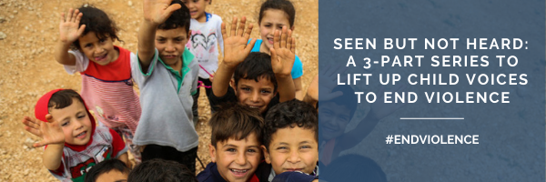
Part 3: A Multi-religious Intergenerational Dialogue on
Child Participation
Tuesday, November 17th
8 AM ET/1 PM GMT/ 4 PM EAT

Agenda:
Welcome and Introduction to the JLI Ending Violence Against Children (EVAC) Hub and the Seen But Not Heard Series (5 min)
• Carola Eyber, Queen Margaret University and JLI EVAC Hub co-chair

Intergenerational Dialogue (20 min) Moderated by Neelam Fida, Islamic Relief Worldwide and JLI EVAC Hub Co-chair
- Children from Baha’í Community, Chile (video)
- Children from Muslim Community, Pakistan (video)
- Children from various Faith Communities, South Africa
Reflections & Q&A (10 min) Moderated by Neelam Fida
- Christina Nomdo, Commissioner for Children, Western Cape, South Africa
- Loreto Jara, Bahá’í, Chile
- Afshan Jamal, Islamic Relief, Pakistan
Closing and invitation to JLI EVAC Hub, Stacy Nam, Joint Learning Initiative on Faith and Local Communities
Co-hosted by:
JLI Ending Violence Against Children Learning Hub: Arigatou International, Islamic Relief Worldwide, Queen Margaret University, and World Vision International
Simultaneous interpretation English-Spanish-English will be available.
View prior events and resources at https://evac.jliflc.com/evac-hub-evidence-guide/
Register Today!
